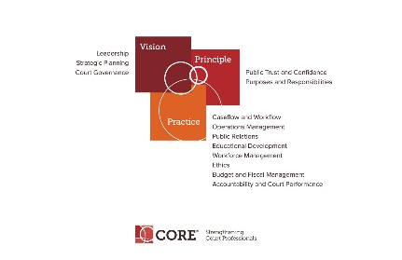

CORE COMMITTEE
Wednesday, April 25, 2018

3:00 P.M. ET
800-503-2899 Access Code: 2591537#

AGENDA

- Curricula Review Process – Janet Cornell and Judy Ly

- Core Presentation at Annual – Status of Session

- Core Website and Core News

- Happening around NACM

- Core Committee webpage: https://nacmnet.org/committees/core/page.html

- Next Meeting May 23, 2018 at 3:00 p.m. ET

