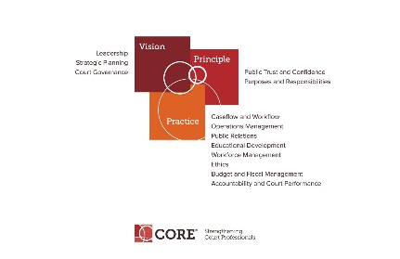

CORE COMMITTEE
Wednesday, January 23, 2019

3:00 P.M. ET
https://nacmnet.org/committees/standing-committees/education/core-committee/

Please join my meeting from your computer, tablet or smartphone. https://global.gotomeeting.com/join/335237197
You can also dial in using your phone.
United States: +1 (646) 749-3122
Access Code: 335-237-197
Joining from a video-conferencing room or system?
Dial: 67.217.95.2##335237197
Cisco devices: 335237197@67.217.95.2
First GoToMeeting? Let's do a quick system check:
https://link.gotomeeting.com/system-check

AGENDA

- Curricula Review Process – Status of next two reviews by Sub-committee

- Core Presentations at Mid-Year Conference – Accountability and Court Performance, Workforce Management

- Core Website and Core News

- Education Committee Update

- Happening around NACM. Board Nomination and Declarations Open: https://nacmnet.org/who-we-are/leadership/board-candidacy/

- Next Meeting February 27, 2019 at 3:00 p.m. E.T.

