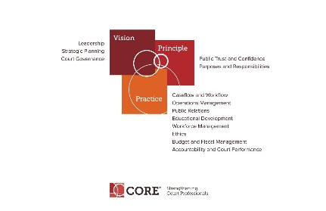

CORE COMMITTEE
Wednesday, June 27, 2018

3:00 P.M. ET
800-503-2899 Access Code: 2591537#

AGENDA

- Curricula Review Process – Status of Accountability and Court Performance - Judy Ly. Status of Public Trust (forming of group) – Janet Cornell

- Core Presentation at Annual – Status of Session

- Core Website and Core News

- End of Year Committee Goals.

- Happening around NACM

- Core Committee webpage: https://nacmnet.org/committees/core/page.html

- Next Meeting TBD

