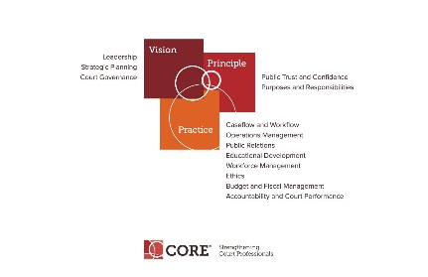

CORE COMMITTEE
Wednesday, May 29, 2019

3:00 P.M. ET
https://nacmnet.org/committees/standing-committees/education/core-committee/

Please join my meeting from your computer, tablet or smartphone.
https://global.gotomeeting.com/join/925566565
You can also dial in using your phone.
United States: +1 (872) 240-3212
- One-touch: tel:+18722403212,,925566565#
Access Code: 925-566-565
Joining from a video-conferencing room or system?
Depending on your device, dial:
925566565@67.217.95.2 or 67.217.95.2##925566565
New to GoToMeeting? Get the app now and be ready when your first meeting starts: https://global.gotomeeting.com/install/925566565

AGENDA

- Curricula Review Process – Status of reviews by Sub-committees

- Core Presentations at Annual Conference – Governance and Public Trust and Confidence

- Education Committee Update – Core Curricula Certification Report from Sub-Committee

- Happening around NACM. Annual Conference July 21-26.

- Next Meeting at the Annual Conference as part of the Education Committee, July 25, 2019, 11:30-12:30

