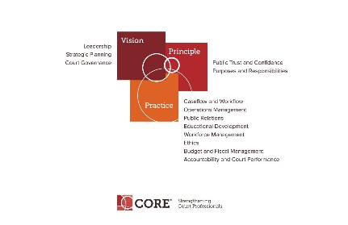

CORE COMMITTEE
Wednesday, January 24, 2018

3:00 P.M. ET
800-503-2899 Access Code: 2591537#

AGENDA

- Curricula Review Process – In need of a volunteer to replace Renee Danser on co-leading this sub-committee

- Core Presentation at Mid-Year – Strategic Planning Curriculum

- Core Website and Core News

- Core Committee webpage: https://nacmnet.org/committees/core/page.html

- Next Meeting February 28, 2018 at 3:00 p.m. – possible conflict

