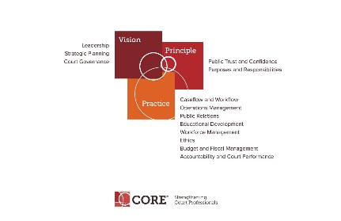

CORE COMMITTEE
Wednesday, October 25, 2017

3:00 P.M. ET
800-503-2899 Access Code: 2591537#

AGENDA

- Curricula Review Process – Status of Caseflow. Next Curricula.

- Core Presentation at Mid-Year – Strategic Planning Curriculum – Kent Pankey

- Power Points on Website status.

- Tool Kits and Self Assessments update

- Core Committee webpage: https://nacmnet.org/committees/core/page.html

- Next Meeting November 22, 2017 at 3:00 p.m.

