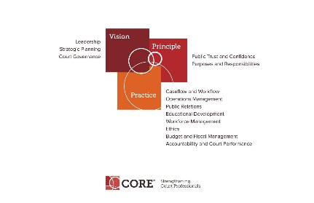

CORE COMMITTEE
Wednesday, September 23, 2017

3:00 P.M. ET
800-503-2899 Access Code: 2591537#

AGENDA

- Curricula Review Process – Janet Cornell and Renee Danser – Status of Project.

- Core Presentation at Mid-Year.

- Power Points on Website status.

- Tool Kits and Self Assessments.

- Core Committee webpage: https://nacmnet.org/committees/core/page.html

- Next Meeting October 25, 2017 at 3:00 p.m.

