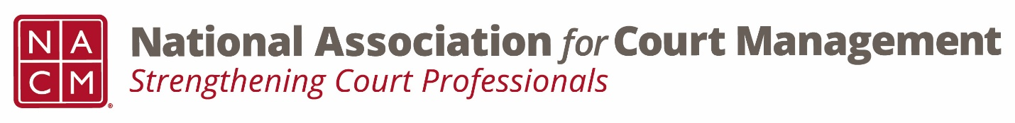

CORE COMMITTEE
Wednesday, January 22, 2020
3:00 P.M. ET

MEETING MINUTES

Call Participants:
Kelly Hutton Hope Kentnor Janet Reid
Kent Pankey Norman Meyer Peter Kiefer
Phillip Knox Peggy Gentles Janet Cornell
Brandon Kimura Kathy Griffin Judy Ly
Dorothy Howell Will Simmons Rick Pierce
Jeffrey Tsunekawa

- Welcome, Roll Call and approval of the December 11, 2019 Minutes
Kent offered up a couple of friendly amendments to name spellings, but with no other objections, the December 11, 2019 meetings were deemed approved.

- Curricula Review Updates
  - Purposes and Responsibilities
Since the last call, Ed McNachtan from Ohio had stated that if no one else volunteered to lead the subcommittee, he would be willing. As he was not on the call, Jeffrey will follow-up to officially appoint him as lead on the review committee. Phil Knox and Janet Cornell had previously volunteered to review. Peggy Gentles and Dorothy Howell also volunteered to assist in any way that was helpful.
  - Operations Management
Brandon Kimura gave an update on the current review process. The group has already had their first meeting to go over the initial sections, and have good momentum moving forward. Peter Kiefer, Judy Ly and Kelly Hutton are reviewers for the group.
- CORE Micro Courses Update
Jeffrey provided a summary of the initial meeting of the subcommittee that met to discuss the CORE Micro Courses last December. The group had some high-level discussions about what a partnership and governance could look like and briefly discussed other areas that would need to be decided, such as content approval and branding. The group then discussed whether or not the NACM Board would consider other organizations or entities that might be able to deliver the same product. Jeffrey and Jeff Chapple communicated that the Board would have to do its due diligence and likely issue an RFP to see if there are any other options worth considering. With that, the subcommittee decided it was best out of any conflict-of-interest to pause the conversations and receive further direction from the Board on how to proceed.

The NACM Officers discussed the issue during their December call, and decided to move it forward for further discussion at the Midyear Board meeting in early February.

Norman asked for clarification on whether or not the Board already decided how they were moving forward in terms of a partnership or not. Jeffrey clarified that the Board has not had full discussion since October, and that these types of details would need to be decided during the development of an RFP/RFO. There was a lot of discussion about the importance of sorting through the details and keeping the conversation continuing.

Phil suggested that NACM consider developing a statement about mutual understanding on oversight and management should they go forward with a request for proposal. This could help provide clarify going forward.

There was a question raised as to whether or not any follow-up had been done with NCSC or ICM. Jeffrey stated that his understanding was that NCSC has been looped-in on all discussions regarding the micro courses. NCSC staff are at the table at all NACM Board meetings and calls. Norman stressed that he felt it was important to still touch base with both NCSC and ICM to have a conversation about this project.

- Other Business
Kent inquired whether the Core Champion program was moving forward or if it was on hold pending the details of the Micro Courses. Jeffrey initially stated that since the two complement each other, it seemed that it should wait. Several committee members gave the opinion that it should progress forward regardless. The initial proposal that was approved is of no cost and will benefit the membership. With the committee’s direction, it was decided to keep the Core Champion on a forward path. Janet and Kent were on the original group that came up with the proposal and both agreed to work on implementation. Jeffrey and Kathy will look to see who other members were to see if they were interested in continued participation. This will become a standing item for update on future committee calls.

Meeting adjourned at 2:55 pm.

NEXT Meeting: February 26, 2020, 3:00 PM ES

