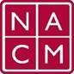
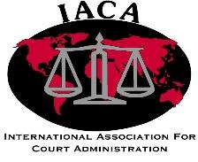
National Association for Court Management
International Association for Court Administration

Court Association Formation Template Summary Version
Prepared by the National Association for Court Management
International Committee

- Group Formation  - Purpose and Goal.  - Legal Authority.  - Parliamentary Procedures.  - Code of Ethics. | - Group Operations and Financial Practices  - Clerical Support.  - Membership Dues/Fees.  - Organization Financial Management.  - Establish Mailing Address/Location.  - Establish Web Presence and/or Online Access
- Group Structure  - Group Leadership.  - Group Membership.  - Committees. | - Group and Organizational Activities  - Group Products.  - Outreach/Marketing.  - Access Channels.  - Technology Support.  - Meetings.  - Educational Programming.  - Organizational Maintenance.  - Organizational Expansion.

Glossary (Preliminary or Representative Sample)

- Mission, vision – (definition)
- Articles of incorporation, by-laws – (definition)
- Parliamentary procedures – (definition)

