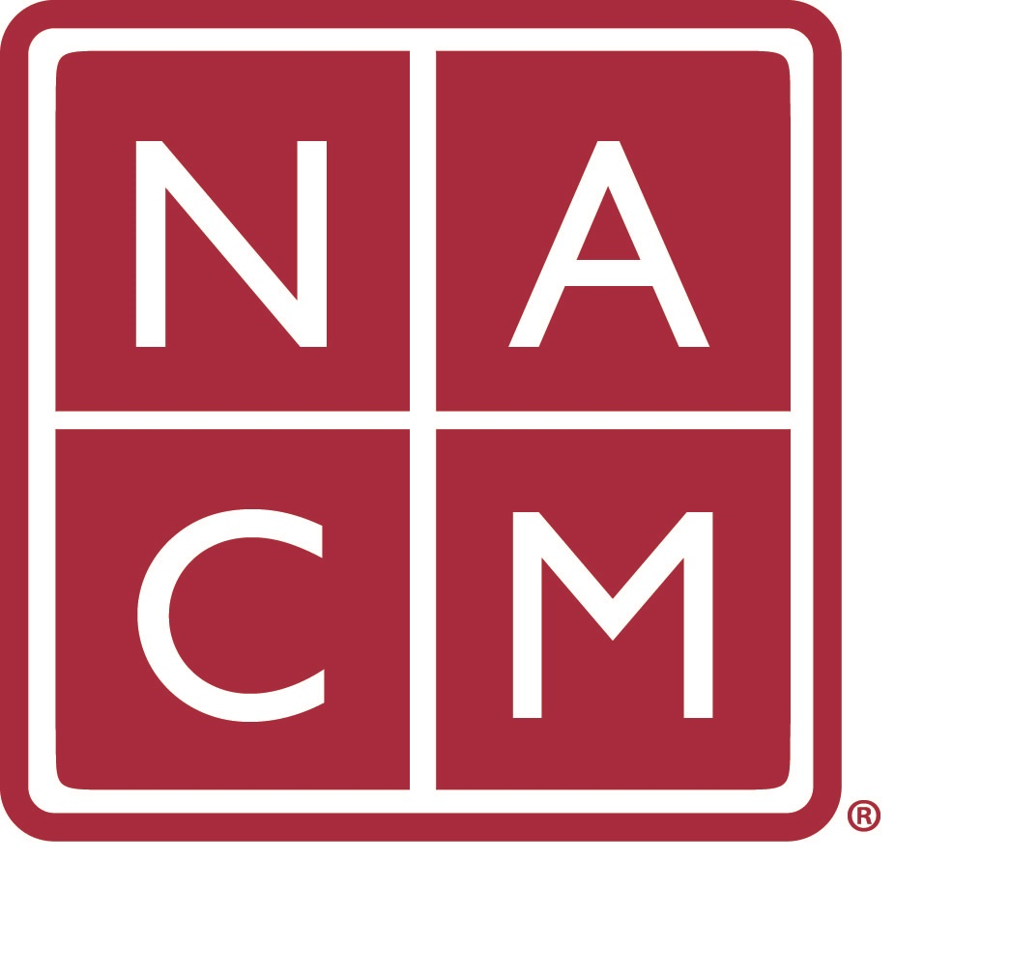

National Association for Court Management (NACM)

Conference Crisis Response Plan

Prepared for: NACM Annual Conference 2018, July 22-26, 2018

Atlanta, Georgia

Table of Contents

1. **Objective**
2. **Purpose**
3. **Internal Communications**
4. **Public Communications**

#### Crisis Level

#### Level 1

#### Level 2

###### Crisis Response Personnel

###### Crisis Management Team

###### Conference Management

###### Key Staff

* 1. CPR/AED Certified Staff
  2. Local Security & Emergency Contacts
  3. Additional Resources

1. **Crisis Management Team Members Responsibilities**
2. **Destination & Facility Plan**
   1. Evacuation Plans
   2. Shelter in Place Plan
   3. ADA Compliance
   4. Onsite First Aid Locations & Hours
   5. AED Locations
3. **Potential Crisis Situations and Procedures**
4. **Cancellation Plans**
   1. Prior to Move-in
   2. During Move-in
   3. During Event- Transportation Limited
   4. Cancellation Once Meeting has Begun
5. **Crisis Analysis Summary & Financial Impact**
6. **Objective**

NACM provides this document to provide guidance and structure to Staff, Volunteers and Conference Attendees as they address issues and options being faced by travel during crisis or critical incidents. The development of effective and efficient crisis response and crisis management procedures is predicated upon preparedness, pre-planning, recognizing options, training and a vigilant perception of the world in which we live. This document is updated each year, with current facility and destination specific information.

1. **Purpose**

The purpose of this document is to provide standard procedures for Staff, Volunteers and Attendees to prepare for and respond to emergency situations. The Conference Crisis Response Plan is a working document and will be continually reviewed, revised and rewritten as necessary.

1. **Internal Communications**

NACM Board of Directors and contracted staff (See page 5) on-site will be advised of a meeting point in the event of emergency. In the event of an emergency, staff members should remain alert for a text message regarding a location to meet (expected to be the staff office unless not available) and how to move forward. The NACM Spokesperson will also be asked to join.

Contact information, emergency contact information and dietary/medical information of all attendees is kept as provided in a binder onsite, but also in NCSC association database. Registration staff should have a printed copy of this information at all times should loss of power, evacuation or off-site event occur. Exhibitor attendees follow the same protocol as advised by the Exhibits Manager as noted on page 5. A comprehensive list contact will reside with the Association Manager as well.

The event team, consisting of the Conference Manager and Association Manager, will meet with the venue security team to review procedures prior to the meeting. This document should be kept at the registration desk as well as with the incident commander. A copy should be given to the conference facility.

Should a disruption occur on site, there should be a safe word or phrase that you have established with your Conference Services Manager or hotel contact.

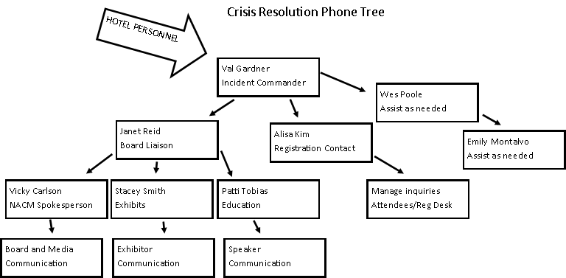

1. **Public Communications**

To ensure a consistent message, it is important that all communications are directed to the assigned NACM Crisis Management team (see page 5) The Media Contact, designated by NACM will manage all communication with the press and general public.

When discussing a particular crisis situation, all staff members should be cognizant of their surroundings and who may be within listening distance. Radios/walkie talkies should not be used to communicate the details of an emergency. Please use cell phones or text to communicate emergencies. (what if there is a cellular breakdown?) then what?

If a concerned volunteer, attendee or exhibitor approaches a staff member, our response should be accurate without causing alarm. If the situation becomes critical – staff must relax, be calm, and explain to the person(s) that a member of NACM will be making an official statement in the near future.

1. **Crisis Level Definition**

Different crises require different responses. Specific scenarios listed in this document should be labeled Level 1 and Level 2.

**Level 1** – Situations that can be contained and resolved by NACM staff, facility personnel and contract security, without widespread action, public statement, risk or event disruption. Examples include: injury or illness limited in scope, routine theft, and limited disruptive behavior. Level 1 situations are likely to be reported to NACM staff, facility and vendor personnel who are advised to report any situations to the Conference Management Office. The incident commander at each facility, in conjunction with facility and vendor personnel will take appropriate action. Level 1 situations do not require the activation of the full Crisis Management Team, however, the Team will be notified of a Level 1 event as these events may move from Level 1 to Level 2 at any time.

**Level 2** – Situations that require higher level decision-making, event postponement, public statement, or have the potential to cause panic, injury, or controversy. Examples include hurricane, terrorist activities, or transportation disruption. Level 2 situations are likely to be learned about from external sources such as the media, Internet, volunteers and attendees. As soon as a potential incident is identified, facility contact staff and crisis management team should be notified. Individuals inquiring about said situation will be advised that the situation is being reviewed and instructions are forthcoming.

1. **Conference Crisis Response Personnel & Contacts**

**Conference Crisis Management Team**

The Conference Crisis Management Team is composed of the individuals listed below and is responsible for reviewing and maintaining this document, monitoring threats and hazards and serving as the response team onsite in the event of an actual crisis or emergency.

|  |  |  |
| --- | --- | --- |
| **Name** | **Responsibility** | **Cell Phone** |
| **Val Gardner**  **Conference Manager** | Incident Commander  Event Logistics Contact | 757-262-8693 |
| **NACM President, Vicky Carlson** | Media Contact or Designee | 952-807-2294 |
| **Association Manager**  **Janet Reid** | Board Liaison | 757-817-8967 |
| **Conference Registrar**  **Alisa Kim** | Registration Contact | 303-258-6149 |
| **Exhibits Manager**  **Stacey Smith** | Exhibitions Contact | 757-268-1142 |
| **Education Coordinator**  **Patti Tobias** | Speaker Contact | 208-830-7661 |
| **Paul DeLosh** | NACM President Elect | 804-349-9652 |
| **Wes Poole, CLM** | As Needed | 804-986-6071 |
| **Emily Montalvo, CLM** | As Needed | 757-784-7994 |

**Key Staff Not Onsite to Assist with Crisis**

|  |  |  |
| --- | --- | --- |
| **Name** | **Responsibility** | **Cell Phone** |
| **Director of Conferences & Association Services** | **Jennifer Haire** | **703-282-8506** |
| **NCSC Director of Communications** | **Jesse Rutledge** | **757-903-5490 (cell)**  **757-259-1505 (work)** |

**CPR/AED Certified Staff**

|  |  |
| --- | --- |
| **Name** | **Cell Phone** |
| **Hotel Front Desk** | **Hotel house phone number 66** |
| **All Security Staff** | **Hotel house phone number 66** |

**Local Security & Emergency Contacts**

|  |  |  |
| --- | --- | --- |
| **Name** | **Location** | **Phone** |
| Michelle Evans  Senior Event Manager - Events | Hilton Atlanta  255 COURTLAND STREET NE, ATLANTA, GEORGIA, 30303, | **404 221 6397** |
| Evacuation Rally Point (in the event it is required to leave the building) | The hotel is divided into **zones** and each zone is equipped to detect and contain smoke and or fire. In the event of activation an alarm will sound as well as strobe lights. Guests will be instructed as to the nature of the situation by an announcement through the fire panel public address system. Atlanta Fire Department is immediately notified to respond to the hotel. The hotel crisis committee and in house emergency response team will respond to the area. All individuals are to standby for further instructions form the public address system. When the situation is declared all clear guests will be informed to proceed with normal activity. If for any reason the hotel or one part of the hotel must evacuate, instructions will be given via the facility’s public address system. Once the announcement is made, please exit quickly but calmly following the directions of the public announcement and of the Hilton Atlanta staff in the area. Stairwells lead down to the outside of the building exiting to **Baker Street on the north side of the complex and Harris Street to the south side**. Hotel guests will be directed by Hilton Atlanta team members to the **Marriott hotel for shelter, safety and accountability**. All guests will remain at the Marriott until Hilton Atlanta staff advises that it is safe to return to the Hilton | |
| Security |  | **Internal Number 66**  **404-221-6379** |
| First Aid |  | Internal Number 66  404-221-6379 |
| Loss Prevention |  | Internal Number 66  404-221-6379 |
| Urgent Care | SmartCare Urgent Care | Emory Healthcare Network – Midtown  450 14th St NW, Atlanta, GA 30318 | (404) 480-9797 |
| Hospital | Emory University Hospital Midtown  550 Peachtree Street, NE  Atlanta, GA 30308 | 404-686-4411 |
| Local Pharmacy | CVS  235 Peachtree Street, NE  Atlanta, GA 30303 | 404-577-4054 |
| Local Police Department | Atlanta Police Department Zone 5  200 Ted Turner Dr NW,  Atlanta, GA 30303 | 404-658-7830  911 |
| Local Fire Department | Atlanta Fire Station 4,  309 Edgewood Ave SE, Atlanta, GA 30312 | 911 |
| Insurance Company Contact Number & Policy # | TYNESHIA WELLS  Account Representative-Commercial USI Insurance Services 9020 Stony Point Parkway Suite 202 Richmond, VA 23235 | o: 804.729.9812 | f: 610.537.2312  Tyneshia.Wells@usi.com |

**Additional Resources**

**Crisis Text Line**[crisistextline.org](http://www.crisistextline.org/how-it-works/) **FREE 24/7 SUPPORT**  
Crisis text line serves anyone, in any type of crisis, providing access to free, 24/7 support and information via the medium people already use and trust: Text. Here’s how it works:

1. Text 741-741 from anywhere in the USA, anytime, for any crisis.  
2. A live, trained Crisis Counselor receives the text and responds quickly.

**RAINN (Rape, Abuse & Incest National Network)**[rainn.org](http://www.rainn.org)   
National Sexual Assault Hotline  
800-656-HOPE (4673)

**Directory of State Sexual Assault Hotlines**  
[feminist.org/911](http://www/feminist.org/911)  
Directory of crisis center hotlines in the USA.

**FEMA and Department of Homeland Security**  
[fema.gov](http://www.fema.org) and [dhs.gov](http://www.dhs.gov)  
Multiple resources available such as storms, earthquake, fire, cybersecurity, terrorism, active shooter, transportation etc.

**7. Conference Crisis Management Team Members Responsibilities**

In case of an actual emergency or crisis, the Crisis Management Team will serve in the following roles:

**Incident Commander (Conference Manager; Back Up: Association Manager):** Act as the Crisis Management Team chair and is in charge until or unless this person relinquishes his or her role to another member of the team. Shall serve as the liaison to the Association Manager and the rest of Crisis Management Team and will be the main medical emergency contact. Provides continuous communication to staff members onsite and at the headquarter office to keep them apprised of the crisis or emergency.

**Media Contact (NACM Designate, Back Up: NACM Designee):** Is responsible for crafting and disseminating an accurate and uniform message and discouraging unauthorized statements to the media. Monitors news and communicates with the team. Manages onsite press and distributes press releases. Prepares a position statement and identifies individuals who are willing to be interviewed on behalf of NACM. Responsible for news content on the NACM website(s), email blasts, app notification with support from Association Manager.

**Event Logistics Contact (Conference Manager; Back Up: Association Manager):** Liaison to all hotels, conference vendors (i.e. outside events/transportation companies), convention center, and city to keep them apprised of the crisis or emergency.

**Registration Contact (Conference Registrar):** Communicates and sets up an emergency help desk to provide information to all individuals onsite to keep them apprised of the crisis or emergency. If needed, communicates with hotel concierge and area travel agencies to set up emergency travel services help desk to provide information to all individuals onsite about airports, hotels, car rentals, trains, buses, and ride-sharing.

**Educational Coordinator (NACM Education Consultant; Back Up: NACM President-Elect)**: Communicates with speakers and moderators by phone, email and in person to keep them apprised of the crisis or emergency.

**Exhibitor Contact (Exhibit Manager; Back Up: Conference Registrar):** Communicates with all exhibitors by phone, email, and in person to keep them apprised of the crisis or emergency.

**All Conference Crisis Team Members:** Assist with the above communications and procedures where needed and assigned.

**8. Destination & Facility Plan**

* 1. **Evacuation Plans**

In the event of a serious emergency, it may become necessary to evacuate the building. Should that happen, you will receive instructions about what to do and where to go from the Hotel Crisis Management Team and/or the Public-Address System.

If evacuation is needed, use the closest marked “EXIT” or follow directions from building personnel. The evacuation or rally points can differ depending on where in the building the emergency is taking place. All staff/attendees will rally in the self-parking lot for any events that require evacuation (evacuation map at the end of this document.) roll call will be taken. If for some reason that location is inaccessible to you please go to the nearest safe location and text/call the incident commander (Val Gardner) with your location and status.

Incidents that may require evacuating the building include:

* Fire
* Bomb threat/suspicious package/suspicious mail
* Explosion
* Weather related emergency (with advanced notice)
* Chemical or Biological Incident

Chain of command for determining emergencies varies day to day based on hotel staff present and what the emergency is. In general, decisions will always be made collaboratively by members of the hotel emergency response team.

The key to a successful evacuation is to remain calm and follow directions. Conference Crisis Management Team will gather together with the spokesperson to determine next steps after evacuation to include: messaging, contacting attendees, speakers and exhibitors.

**b. Shelter in Place Plan**

Incidents that may require shelter in place include:

* Weather related emergency
* Civil Disturbance
* Suspicious package/suspicious mail
* Chemical or Biological Incident
* Hazardous material

Shelter-in-place means selecting a small, interior room, with no or few windows, and taking refuge there. If you are told to shelter-in-place, follow the instructions provided over the PA system.

**c.** **ADA Compliance**

The Americans with Disabilities Act (ADA), requires that both the conference facility and NACM provide accessible accommodations to disabled persons.

**d. Onsite First Aid Locations & Hours**

First aid locations are provided at multiple department locations throughout the Hotel and the master inventory and supplies are kept at First Aid.  Any need for Medical supplies and Emergency please call 66, if it is an emergency dial 66. This is available 24/7. Please see front desk for any first-aid needs. Front desk will call security if needed.

|  |  |  |
| --- | --- | --- |
| **Location** | **Phone** | **Hours** |
| **Onsite First Aid**  **Hotel Lobby – Front Desk** | **From Outside Hotel: 404-221-6379 (Operator can then transfer to the front desk)**  **From Inside Hotel: Dial 66**  **EMERGENCY: Dial 66** | **24 Hours** |

**e. Automated External Defibrillators (AED) Locations**

An automated external defibrillator (AED) is a portable device that checks the heart rhythm and can send an electric shock to the heart to try to restore a normal rhythm. AEDs are used to treat sudden cardiac arrest (SCA). SCA is a condition in which the heart suddenly and unexpectedly stops beating.

Anyone who has minimal CPR and AED training can use an AED to help save a life.

**9. Cancellation Plans**

In the event of a crisis or emergency warranting cancellation of the Meeting, all staff members and other key personnel will report to the Conference Management office. If the conference facility is evacuated, report to Self-Parking Lot.

**a. If the Meeting needs to be canceled prior to the start of move-in:**

* All key personnel will meet in the Conference Management office to review implementation of cancellation plans or by conference call prior to arriving onsite
* Incident Commander enacts Emergency Phone Tree to inform all staff members of the cancellation and provide further instructions
* Media Contact to create a formal statement outlining the decision for cancellation and further actions, if necessary
  + Staff members and key personnel should use script provided to answer questions from individuals
  + Staff members and key personnel should state provide as much accurate information as available, or refer them to Media Contact for any questions asked by the media or press.
* Media team (Spokesperson, Association Manager, Conference Manager) will handle communications that should go out immediately to all individuals planning to attend the Meeting
  + A message announcing the cancellation will be posted on the NACM Main and Conference Websites, as a push notification through the conference app, and through an email blast.
* All staff members will update their voicemail at the office and their hotel room telephones with the same statement as well as their out of office response for email.
* Facility personnel and staff members assigned will be at entrances to the convention center to let individuals know, who may not have received the message, that the Meeting has been canceled
* Hotel personnel will send a message to all guest rooms that have already checked in to the event.
* Conference Manager (in conjunction with Media Contact) will post cancellation information in key locations in facility
* Registration Contact and Exhibitor Contact will put into place policies for refunds of exhibitor and registration fees
* Incident Commander will contact the facilities, legal counsel, and the insurance company to alert them of the cancellation
* Event Logistics Contact will provide written notice by email of the cancellation to all facilities impacted by this decision (i.e. hotels, restaurants, CVB, etc.)
* Meetings with all staff members and key personnel will continue on a frequent basis as long as necessary to keep them updated on the situation

**b. If the Meeting needs to be canceled during move-in:**

* All key personnel, will meet in the Conference Management office to review implementation of cancellation plans
* Incident Commander enacts Emergency Phone Tree to inform all board, speakers, exhibitors and attendees of the cancellation and provide further instructions if necessary
* Media Contact to create a formal statement outlining the decision for cancellation and further actions, if necessary
  + Staff members and key personnel should use script provided to answer questions from individuals
  + Staff members and key personnel should state provide as much accurate information as available, or refer them to Media Contact for any questions asked by the media or press.
* Media Contact will handle communications that should go out immediately to all individuals planning to attend the Meeting. Association Manager will assist as necessary.

A message announcing the cancellation will be posted on the NACM Main Website and Conference website, conference app, and an e-blast will be sent.

* All staff members will update their voicemail at the office and their hotel room telephones with the same statement as well as out – of – office email messages
* Event Logistics Contact will provide information of the situation to all hotels impacted
  + Hotels will be asked to extend the convention rate as long as necessary
* Exhibitor Contact will contact exhibitors and inform them in writing via email of the cancellation
* Facility personnel and staff members assigned will be at entrances to the convention center to let individuals know, who may not have received the message, that the Meeting has been canceled
* Conference manager, in conjunction with Media Contact, will post cancellation information in key locations in facility
* Registration Contact and Exhibitor Contact will put into place policies for refunds of exhibitor and registration fees
* Incident Commander will contact the facilities, legal counsel, and the insurance company to alert them of the cancellation
* Event Logistics Contact will contact the shuttle bus company to set up transportation to hotels and/or airports for staff members.
  + To the extent possible, buses can be used to arrange transportation for individuals attending or providing service to the Meeting, that will be done
* Event Logistics Contact will provide written notice by email of the cancellation to all facilities impacted by this decision (i.e. hotels, restaurants, CVB, etc.)
* Meetings with all staff members and key personnel will continue on a frequent basis as long as necessary to keep them updated on the situation

**c. If it is determined that the Meeting should progress until conclusion, but transportation home is limited:**

* Conference Crisis Management Team, will meet in the Conference Management office to confirm a plan of action
* Incident Commander enacts Emergency Phone Tree to inform all staff members of the situation and provide further instructions
* Media Contact to create a formal statement outlining the decision and further actions, if necessary
  + Staff members and key personnel should use script provided to answer questions from individuals.
  + Staff members and key personnel should state provide as much accurate information as available, or refer them to Media Contact for any questions asked by the media or press.
* Incident Commander or venue will make announcements on the public-address system throughout the facility of the decision to continue the Meeting until conclusion
* Media Contact will handle communications that should go out immediately to all individuals attending the Meeting
  + A message announcing the decision of continuing the Meeting will be posted on the NACM Main Website and Conference Website, through push notification on conference app, and through an email blast
* All staff members will update their voicemail at the office with the same statement
* Event Logistics Contact will provide information of the situation to all hotels impacted
  + Hotels will be asked to extend the convention rate as long as possible
* Media Contact will post cancellation information in key locations in facility
* Exhibitor Contact will communicate with the exhibitors and speakers about the importance of staying the course
* Continued communications sent out by the Media Contact will assure all individuals that the scheduled events will be held as planned
* Building evacuation plans, provided by the facility contact, will be on hand should that become necessary
* Event Logistics Contact will contact the shuttle bus company to set up transportation to hotels and/or airports for staff members.
  + To the extent possible, buses can be used to arrange transportation for individuals attending or providing service to the Meeting, that will be done
* Incident Commander will contact the facilities, legal counsel, and the insurance company to alert them of the situation
* Event Logistics Contact will provide written notice by email of the situation to all facilities impacted by this decision (i.e. hotels, restaurants, CVB, etc.)
* Meetings with all staff members and key personnel will continue on a frequent basis as long as necessary to keep them updated on the situation

**d. If the Meeting needs to be canceled once the meeting has begun, and if transportation is curtailed:**

* All key personnel, will meet in the Conference Management office at the conference venue to review implementation of cancellation plans
* Incident Commander enacts Emergency Phone Tree to inform all staff members of the cancellation and provide further instructions
* Media Contact to create a formal statement outlining the decision for cancellation and further actions, if necessary
  + Staff members and key personnel should use script provided to answer questions from individuals
  + Staff members and key personnel should state provide as much accurate information as available, or refer them to Media Contact for any questions asked by the media or press.
* Media Contact will handle communications that should go out immediately to all individuals attending the Meeting. Assistance from Association Manager as needed.
  + A message announcing the cancellation will be posted on the NACM main and conference website, as a push notification on the conference app, and an e-blast will be sent
  + To the extent possible, personal phone calls will be made to individuals attending the Meeting
* Incident Commander or venue will make announcements on the public-address system in the facility
  + All individuals will be assured that we are providing them with the most accurate information possible in order to help them make their decisions
* Event Logistics Contact will provide information of the situation to all hotels impacted
* Hotels will be asked to extend the convention rate as long as necessary
* Conference Registrar, Exhibit Manger and Hotel designee will set up desk and include hotel policies as well as information on transportation options
* All staff members will update their voicemail at the office and their hotel room telephones with the same statement as well as out of office email replies
* Facility personnel and assigned staff members will be at entrances to the convention center to let individuals know, who may not have received the message, that the Meeting has been canceled
* Media Contact will post cancellation information in key locations in the facility
* Registration Contact and Exhibitor Contact will put into place policies for refunds of exhibitor and registration fees
* Event Logistics Contact will contact the facility catering department contact to see if unused food can be donated or converted to box lunches for individuals and staff members
* Incident Commander will contact the facilities, legal counsel, and the insurance company to alert them of the cancellation
* Event Logistics Contact will provide written notice by email of the cancellation to all facilities impacted by this decision (i.e. hotels, restaurants, CVB, etc.)
* Meetings with all staff members and key personnel will continue on a frequent basis as long as necessary to keep them updated on the situation

**10. Crisis Analysis Summary & Financial Impact**

Complete a full crisis analysis after an emergency has taken place. NACM and all staff members must evaluate how well the situation was handled and investigate additional steps needed to better handle a similar situation in the future.

**Disclaimer**

This Conference Crisis Management Plan is adopted for purpose of guidance and does not constitute a contract or create a cause of action. This Plan does not establish any rights for any director, officer, staff, attendee or employee nor does if create any obligation on the part of the National Association of Court Management or the National Center for State Courts. Furthermore, NACM has the right to change, modify or revoke any or all of the provisions in this Plan unilaterally, in its sole discretion, with or without prior notice. Upon the recommendation of the President of NACM, the Board of

Directors has authority to make exceptions to any of these provisions at any time for any bona fide business reason, except as may be prohibited by law.