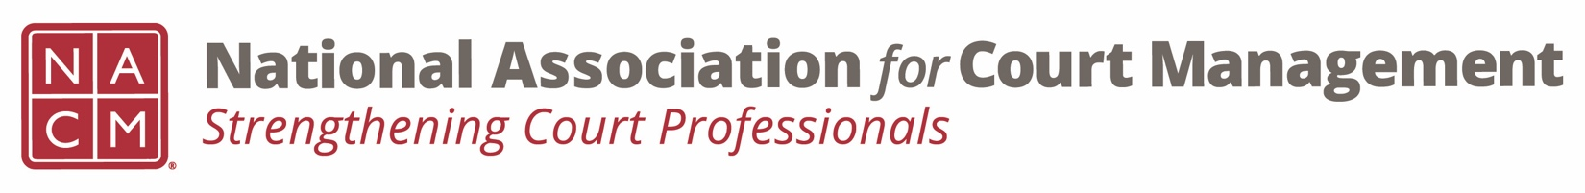
Diversity, Equity & Inclusion Committee
Agenda
August 18, 2022 / 3:00 pm ET
Zoom Meeting Link

- Call to order

- Approval of Minutes & Recap of May 19th meeting and June 18th meeting

- Discussion Topics

  - DEI Updates

    - Education, Resources & Learning Opportunities
      - NACM DEI book club webinar, August 25th: https://us06web.zoom.us/webinar/register/WN_vo4HKC3dRT2VRwFSxePRlA

      - Be a Better Ally – Attachment

    - DEI Collaborative Update
    - DEI Book Club

  - Communications

    - DEI Social Media Outreach – Next 3 months review
    - DEI Webinar(s) – Rick and Sarah to update
    - DEI Guide –

  - Membership – Affinity Groups

  - Projects for the year – discussion/suggestions.

- New Business

- Adjourn

