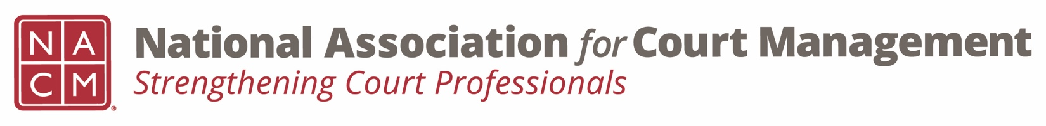
Diversity, Equity & Inclusion Committee
Agenda
September 15, 2022 / 3:00 pm ET
Zoom Meeting Link

- Call to order

- Approval of Minutes of August 18, 2022 meeting.

- Discussion Topics

  - DEI Updates

    - Education, Resources & Learning Opportunities

      - Hispanic Heritage Month https://www.archives.gov/news/topics/hispanic-heritage-month

    - DEI Collaborative Update
    - DEI Book Club – how to proceed

  - Communications

    - DEI Social Media Outreach – Next 3 months review
    - DEI Webinar(s) – Rick and Sarah to update
    - DEI Guide –

  - Membership – Survey results

  - Projects for the year – discussion/suggestions.

- New Business

- Adjourn

