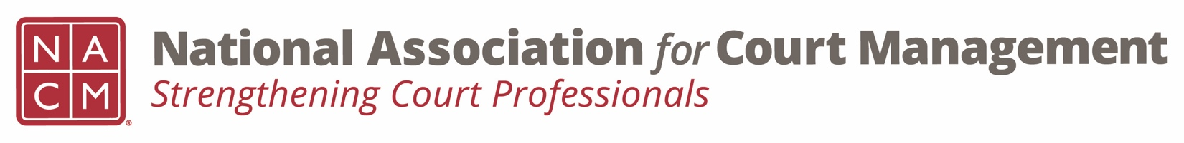
Diversity, Equity & Inclusion Committee
Agenda
November 17, 2022 / 3:00 pm ET
Zoom Meeting Link

- Call to order

- Approval of Minutes of September 15, 2022 meeting.

- Discussion Topics

  - DEI Updates

    - Education, Resources & Learning Opportunities
      - Report from DEI Education in Atlanta, November 9-10
    - DEI Collaborative Update
    - DEI Book Club

  - Communications

    - DEI Social Media Outreach – November is Native American Heritage Month
    - DEI Webinar(s) – Rick and Sarah to update
    - DEI Guide –

- New Business

- Adjourn

