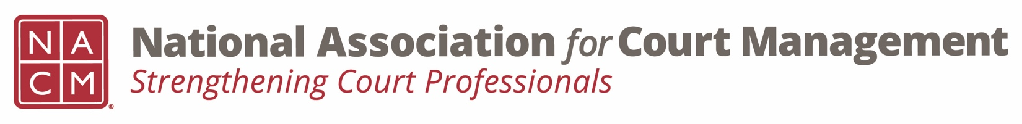
Diversity, Equity & Inclusion Committee
Agenda
December 15, 2022 / 3:00 pm ET
Zoom Meeting Link

- Call to order

- Approval of Minutes of November 17, 2022 meeting https://nacmnet.org/wp-content/uploads/DEI-Committee-Minutes-11-17-22.docx

- Discussion Topics

  - DEI Updates

    - Education, Resources & Learning Opportunities for December https://dignityandrespect.org/universal-human-rights-month/

    - DEI Collaborative Update – no update to report
    - Book club status

  - Communications

    - DEI Social Media Outreach
    - DEI Webinar(s) – Rick and Sarah to update
    - DEI Guide – next meeting December 16, 2022

- Local Court check-in and discussion

- New Business

- Adjourn

