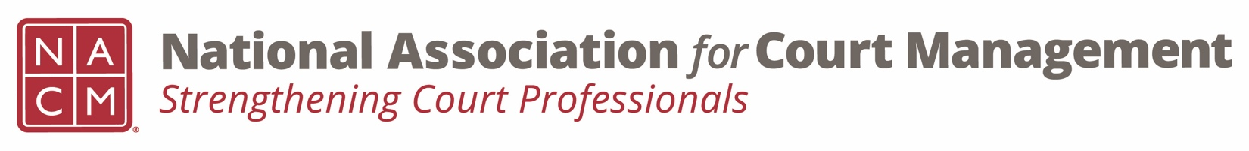
Diversity, Equity & Inclusion Committee
Minutes
August 18, 2022 / 3:00 pm ET
Zoom Meeting Link

- Attendees: Tamela Aikens, Dawn Palermo, Brandon Kimura, Jeffrey Tsunekawa, Sarah Brown-Clark, Ben Burkemper, Kent Pankey, Erin Carr, Roger Rand, Kathy Griffin, Rick Pierce, Lee Ann Barnhardt, Mark Dalton, Jacquetta Adewole, Tina Mattison, TJ BeMent, Stephanie Collier.

- Approval of Minutes & Recap of May 19th meeting and June 18th meeting

  - Minutes for May 19th and June 18th are approved and will be posted.

- Discussion Topics

  - DEI Updates

    - Education, Resources & Learning Opportunities
      - NACM DEI book club webinar, August 25th: https://us06web.zoom.us/webinar/register/WN_vo4HKC3dRT2VRwFSxePRlA

      - Be a Better Ally – Kathy will send this out again.

      - Roger will turn in a request to add a DEI Resources page to the NACM Website under the DEI Committee page. Roger will add existing identified resources provided by Kathy.

    - DEI Collaborative Update
      - Next Meeting is September 1, 2022. Meetings are virtual.
      - They agreed to share what DEI content is being presented by each organization.

    - DEI Book Club
      - How do we manage and organize the book club?
      - Suggestions: Create a book club subcommittee; each person in the book club submits a book and the group votes for the top 12 and they are each assigned a month, the committee members are then assigned a month to facilitate.

  - Communications

    - DEI Social Media Outreach – Next 3 months review
    - DEI Webinar(s) – Rick and Sarah to update
      - History of Courts and Race
        - Webinar Series
        - Conference Presentations
      - Pennsylvania Courts are going to be presenting a series of webinars on this topic.
    - DEI Guide
      - Using Grand funds and NCSC working on securing the experts, in speaking with Jude, the goal is to get the guide done prior to the annual 2023 conference so we can have a breakout session on the guide. We will still be seeking volunteers to review the sections.

  - Membership – Affinity Groups
    - The breakout session at the annual conference had a small turnout because there was another DEI breakout session at the same time.
    - Suggestion of SIG at the mid year on creating safe spaces in your court. We can ask people in that SIG session about creating spaces at the conferences as well.

  - Projects for the year – discussion/suggestions.
    - Board meeting is 9/30, 10/1 and the strategic plan will be discussed which includes DEI.

- New Business
  - New web site subcommittee meets for the first time on 9/7 at 11AM PT/2PM ET. There will be a new sub committee site with a fillable form to submit recommended changes or edits to the existing web site.
  - Call for proposals will be going out in September and deadline will be October 4 for the Mid Year Conference. A subcommittee will review proposals and if you are interested in being on the review committee contact Rick Pierce.
- Adjourn – Next Meeting is 9/15 at 3PM ET.

