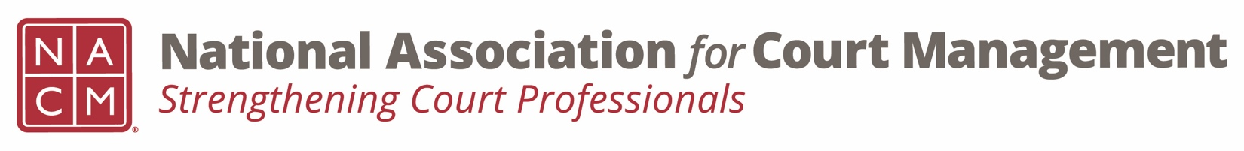
Diversity, Equity & Inclusion Committee
Minutes
September 15, 2022 / 3:00 pm ET
Zoom Meeting Link

- Attendees: Kathy Griffin, Roger Rand, Sarah Brown-Clark, Kent Pankey, Shyra Bland-NJ, Rick Pierce, Norman Meyer, Ben Burkemper, TJ BeMent, Danita Campbell, Eddy Bautista Contreras, Tina Mattison, Kelly Hutton, Brandon Kimura

Introductions: Danita Campbell and Eddy Bautista Contreras from Multnomah Circuit Court.

- Approval of Minutes of August 18, 2022 meeting.

  - Accepted AS/IS

- Discussion Topics

  - DEI Updates

    - Education, Resources & Learning Opportunities

      - Hispanic Heritage Month https://www.archives.gov/news/topics/hispanic-heritage-month

    - DEI Collaborative Update
    - DEI Book Club – how to proceed
      - We need a volunteer to run the book club.
      - Topic of book club? It is good to include as many members as possible so having the topic be different each time may be beneficial. It doesn’t have to be a book – it could be a book, Ted Talk, Movie etc.
      - Timing – perhaps we have a meeting once per quarter. Could we have each NACM Committee sponsor a book club meeting.
      - Forum – Zoom meeting that engages all attendees, break out rooms can be used.

  - Communications

    - DEI Social Media Outreach – Next 3 months review
      - If anyone has any ideas please send Kathy or Roger an email.
    - DEI Webinar(s) – Rick and Sarah to update
      - In the process of securing two speakers for 2023. This will be in cooperation with the NACM Communications Committee. The goal is to offer the first in Q1 of 2023. In order to be more inclusive we will need to do a series of webinars each focusing on a different marginalized community’s experience with the court.
    - DEI Guide – No update. Looking for this by 2023 annual conference.

  - Membership – Survey results
    - Roger went over survey results
    - Discussion about DEI related responses
    - Improving number of survey responses next year
      - Social media, Membership renewal

  - Projects for the year – discussion/suggestions.
    - No comments

- New Business
  - First DEI Convening of DEI Court professionals will be on 11/10 and 11/11 in Atlanta, hosted by NCSC. Edwin Bell is organizing this event. This is an invitation only event and Roger Rand will be attending on behalf of NACM. If anyone on this committee is interested in going please contact Edwin Bell with NCSC.
  - Edwin Bell joined the call. We have a good response from supreme courts and state court administrator offices but we’d like more input from local state courts.
  - Core in practice guide, and Public Relations curricula are being reviewed and revised. Please contact Kelly Hutton if you’d like to be involved: Kelly@nacmnet.org.

- Adjourn

