Attendees: Jacquetta Adewole, Lee Ann Barnhardt, Edwin Bell, Ben Burkemper, Danita Campbell, Valerie Colas, Nicole Garcia, Miha Kapaki, John Laing, Dawn Palermo, Kent Pankey, Shanika Perry, Rick Pierce, Alesia Grace Thompson, Jennifer Wade, Creadell Webb, Dr. Toriarn Weldon
I. Approval of Minutes, April 17, 2024
- Approved
II. Announcements/Introductions
- N/A
III. Continuing Discussion Topics
a. Awareness
- May is Mental Health Awareness Month
  - Mental Health Awareness Month | SAMHSA
  - Mental Health Awareness Month | NAMI
  - Mental health: what are the tools for change? | NCSC
  - Members can download the NACM Behavioral Health Guide here: NACM Store – National Association for Court Management (nacmnet.org). (There is a $10 fee for non-members.)
- May is Asian American and Pacific Islander Heritage Month
  - Asian & Pacific American Heritage Month (asianpacificheritage.gov)
  - FAPAC - AAPI Resources
- May is Jewish American Heritage Month
  - https://jewishamericanheritage.org/

- June Monthly and Daily Observances
-Caribbean American History Month
-LGBTQIA+ Pride Month
-Army Birthday (June 14th)
- Veterans at work certificate program - https://store.shrm.org/SHRM-Foundation-Veterans-at-Work-Certificate-Program
-World Elder Abuse Day (June 15th)
-Juneteenth (June 19th)
When celebrating observances, try to connect them with the Court. For example, you can link Mental Health Awareness month to the health benefits offered in the EAP (Employee Assistance Program).

b. DEI Updates
- Education and Resources
N/A
ii. NCSC – April 24, 2024, to April 26, 2024 Second National Convening of Court Diversity, Equity, and Inclusion (DEI) professionals.
Read the NCSC Newsletter
Court professionals shared best practices and challenges. Politics and legislation around the acronym “DEI” were a constant theme. In those states, it may be beneficial to use other diction that accomplishes the same DEI goals. Language including, but not limited to, the following may be helpful:
- Fairness
- Access to Justice
- Impartiality
- Respect and Civility
- Best practices
- For additional terminology, review your state constitution for terminology that supports DEI goals and initiatives.
DEI professionals were also encouraged to use data to find any disparities within their judiciary.

iii. NCSC - Workshop for Racial Justice Education – April 28, 2024 to May 1, 2024
One judge, one judicial education, and one DEI Court professional from several states were represented at this conference. Attendees received resources and were taught how to have courageous conversations about race.

iv. NACM Customized Inclusivity Training
- Pilot Program: June 20th, Multnomah Circuit Court
Some Courts may get assistance with developing training while other courts may need consultation. In DEI, we must be cautious about overpromising and under delivering.

v. National Consortium on Race and Ethnic Fairness in the Courts (NCREF)
- May 19-22, 2024 Salt Lake City, National Consortium (national-consortium.org)
c. Strategic Campaign Goals
i. Webinars
- September 12, 2024, 3PM Eastern, DEI is More Than Alphabet Soup (DEI, DEIA, JEDI). DEI is not just about acronyms. It’s about creating fair and equitable systems for all stakeholders.

ii. DEI Committee Site
- Please share resources with the committee. If you have any resources to share, please email those to Roger@nacmnet.org or Creadell@nacmnet.org
        - Articles of interest
        - Training Suggestions
        - Websites of Interest
        - DEI related news stories
iii. NACM Annual Conference
- Signature Customer Experience – John Laing/Valerie
This training is normally 7 hours long. In the interest of time, it has been reduced for the conference. However, this will be a very impactful training session.
- SIG Session – Zenell Brown, Roger Rand, Creadell Webb – This session will highlight NACMs DEI committee.
- Checkout the conference agenda for more DEI topics:

iv. Court Manager – DEI article opportunity
- Creadell Webb wrote an article for the summer edition concerning the acronym DEI.
IV. Diversity, Equity, and Inclusion – Mission and Vision Statements
We revisited the question as to whether diversity, equity, and inclusion should be included in NACM’s mission and vision statements or if DEI should have its own mission, vision, and values.

- If NACM’s mission and vision statements are changed, that would require changes to NACM’s bylaws. Changes to the bylaws require a vote from NACM membership. Therefore, a proposal would need to be published by June 20, 2024, giving the membership at least 30 days to vote. If changes are to occur this year, the membership vote would occur on July 22, 2024.

- DEI committee members were encouraged to follow-up with Creadell Webb or Roger Rand if they had any comments later.

- The mission and vision statements that were shared with the committee during the meeting can be found below:

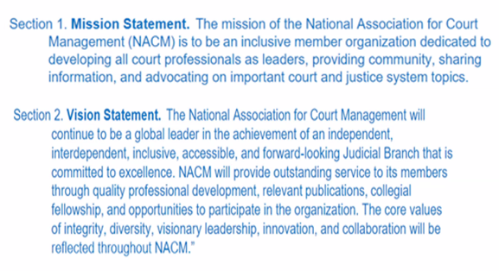
- UPDATE 6/4/2024 – The board met and voted to send the proposed amended Mission and Vision (above) to the general membership at the NACM Annual Conference in July. The membership will need to vote to approve the proposed changes.

V. Local Court Check-in and Round Table Discussion
Philadelphia – Positive Media Attention - Autism in the Courts – CBS News - https://www.cbsnews.com/philadelphia/video/philadelphia-family-court-employees-trained-to-improve-services-for-people-with-autism/.

V. New Business
N/A

VI. Adjourned 4:00PM.

