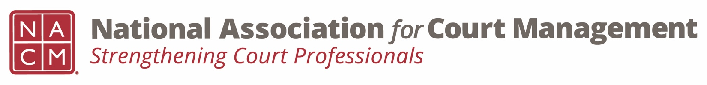
Diversity, Equity & Inclusion Committee
Minutes, November 17, 2022 / 3:00 pm ET

- Call to Order
  - Attendees: Norman Meyer, Roger Rand, Kathy Griffin, Kelly Hutton, Tamela Aikens, Roger Rand, Erica Woodford, Bridget Gazelle, Mark Dalton, Eddy Bautista Contreras, TJ BeMent, Tina Mattison, Zenell Brown.

- Approval of Minutes of September 15, 2022 meeting.
  - On Committee Page. Approved

- Discussion Topics

  - DEI Updates

    - Education, Resources & Learning Opportunities
      - Report from DEI Education in Atlanta, November 9-10
        - Roger gave an overview of event and talked about continuing to promote what NACM offers
        - Other attendees offered their review. Suggestion for NACM conference a great takeaway were the round table discussions where there was a note taker that didn’t move and then all the other attendees moved and met new people. Kathy said that this was done at a prior midyear and it was well-received.
        - Kathy recommended to the CDC that we add this at the lunch hour
        - Kathy provided the following resources and asked that they be added to the Resource index on the NACM site.
          - https://www.racialequityalliance.org/wp-content/uploads/2015/10/GARE-Racial_Equity_Toolkit.pdf
          - https://janeelliott.com/

    - DEI Collaborative Update
      - No update there has not been a meeting.

    - DEI Book Club
      - Janet Cornell is doing a book review in the Court Express. There will be a book posted for review.
      - Suggestion: The Blueprint from Racial Justice has a publication that they suggest quarterly. NCSC provides facilitator notes. NACM can have meetings to review these Blueprint for Racial Justice documents. Tamela Aikens is willing to lead these discussion.

  - Communications

    - DEI Social Media Outreach – November is Native American Heritage Month.
    - DEI Webinar(s) – Rick and Sarah to update
      - Rick and Sarah are looking for someone to work on the webinar and act as a moderator.
    - DEI Guide
      - We’ve had three meetings under our Communications Committee. There are three judges on the committee for input. Need volunteers to work on the output.

- New Business
  - Propose having open discussion as a regular agenda item for this committee. Perhaps a specific discussion topic every meeting. It’s also important to make safe/brave space for committee meeting attendees and important to make space a conferences when difficult subject matter is being delivered.
  - Governance Committee has 5 resolutions up on the website for review and are open for comment until 11/25/22: Resolutions – National Association for Court Management (nacmnet.org).
  - New NACM Conference Site: Conferences – National Association for Court Management (nacmnet.org).

- Adjourn 12:55 PM / 3:55 PM

