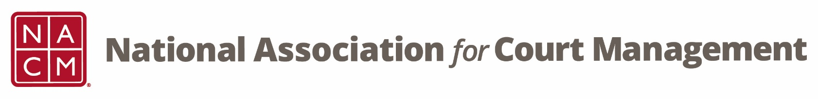

NACM MEMBERSHIP SERVICES COMMITTEE MEETING
Thursday, December 21, 2017 @ 2:00 PM Eastern Time
Via telephone conference: 800-503-2899; Access code: 2591537

- Call to Order – The meeting was called to order at 2:00 pm EST.
- Welcome and Roll Call attendance: Vicky Carlson, Jeff Chapple, Sarah Couture, Kathy Griffith, Leesa McNeil, Michele Oken, Janet Reid, Jeffrey Tsunekawa and Mark Weinberg and Aaron Williamson.

- Membership Incentives and Benefits – The committee was asked to think of benefits and incentives for membership, particularly items that may help offset the cost of membership dues. People should be reminded that it reduces the rate of their registration fee at conferences. It was suggested to use the Court Express as an avenue to communicate member benefits. We need to highlight tangible and intangible benefits, such as guides and scholarships.

- Strategic Initiatives: Demographic Information – Vicky commented that the demographic information has been revisited several times in the past. DOB wasn’t a mandatory field. We need to find ways to use the information. We could include a field for how many years people have been a manager. It’s not uncommon information to collect for grants. A lot of first time members will be coming from LA to the midyear conference.
- 2017 Wrap and Review – three LinkedIn campaigns were executed; second month of Onboarding emails have started; Jeffrey and Sarah have been following-up with non-members who watched the webinars; 3 midyear scholarships were awarded; developing a new website. The Membership Committee was thanked for all of their hard in 2017.
- Around NACM – ECP is looking for volunteers to assist with the ECP First Impressions Team at the midyear conference.
- Next teleconference: Third Thursday of the Month, January 18, 2018 2:00 PM EST
- Adjourn

