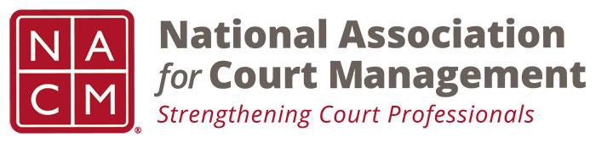

NACM MEMBERSHIP SERVICES COMMITTEE MEETING
Tuesday, December 4, 2018, 11AM ET
1-800-503-2899 Access Code: 2591537

Call to Order Michelle Dunivan
Welcome and Roll Call Michelle Dunivan
GoToMeeting Michelle Dunivan
Board Meeting recap Michelle Dunivan
Recruitment and new member subcommittee Michelle Dunivan
Midyear Conference scholarship Frank Hardester
Mentorship Program Jeffrey Tsunekawa
Data Analysis Michelle Dunivan
Membership Benefits Michelle Dunivan
State Association Agreements Jeff Chapple
Scholarships and Awards review Jeff Chapple
Subcommittees:
- State Associations TJ BeMent
- International Committee Michele Oken
- ECP Angie VanSchoick
New Business

Meeting Schedule
  - December 4, 2018
  - January 8, 2019
  - February 5, 2019
  - March 12, 2019
  - April 9, 2019
  - May 7, 2019
  - June 11, 2019
  - July 18, 2019- At Annual Conference

Adjourn

