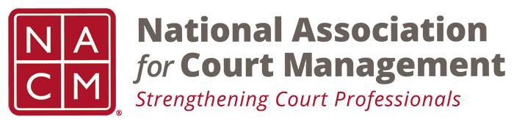

NACM MEMBERSHIP SERVICES COMMITTEE MEETING
Tuesday, December 4, 2018, 11AM ET
1-800-503-2899 Access Code: 2591537

Call to Order Michelle Dunivan
- Randall Soderquist
- Vicky Carlson
- Julie Nelson
- Frank Hardester
- Charleston Carter
- Stacy Hoskins
- Jeffrey Tsunekawa
- Renee Danser
- Janet Reid
- Jeff Chappel

Welcome and Roll Call Michelle Dunivan
Last meeting minutes (attachment)

GoToMeeting Michelle Dunivan

Board Meeting recap Michelle Dunivan

Recruitment and new member subcommittee Michelle Dunivan
New, renewing, exiting, retiring, webinar/conference non members
- Developing scripts
- Establish expectations and protocols
- Leave it on agenda
Midyear Conference scholarship Frank Hardester
- Reviewing on Thursday
- Received 2 applications, both could be awarded
Mentorship Program Jeffrey Tsunekawa
- Status quo- needed direction;
- Handful of people need to be connected with a mentor
Data Analysis Michelle Dunivan
What data to collect, exit survey; state map analysis
- Muni, state, fed, tribal
- Tenure with court/court system
- Title/ manager, supervisor, admin
- Already have general information tab; engineering team is trying to get the information pulled out; however, people aren’t updating fields, so it’s static
- Looking at titles might be not the most telling
- Could have this on the app to see who is at the conference
  - App doesn’t feed database, but would be able to generate reports
  - Polling feature on app; event centered app
  - Need unique identifier
- State level-macro analysis
Membership Benefits Michelle Dunivan
Membership Appreciation
- Activity could be to update profile information
- Between midyear and annual
- Focus on publications and highlighting local jurisdictions
- Highlighting communication committee members; could do this for the whole organization; spotlight member of the day
- Also highlighting non-members
- Social media for this week, but also regularly to highlight people and their courts
  - Points possibility
  - Kevin Lane is going to each state and courts to find their social media. Reciprocal.

Website- clear access to guides, publications, webinars; written justification; VOP results
Promotion Video
- Midyear movie stars
State Association Agreements Jeff Chapple
- Sent last week; hoping to get responses shortly
Scholarships and Awards review Jeff Chapple
- Met October
- Add consistent application date
- Add consistent contact person
- Removed panel review names for 2; didn’t want that to influence participation
- Simplify notices
- Jeffrey will draft nomination form
- Justice Achievement; candidate for rebranding/renaming about court solutions
- Reflect national effort
- Reviewing other organization review processes
- Final submissions to the committee, and will have something to review in January and February
Subcommittees:
- State Associations TJ BeMent
- International Committee Michele Oken
  - SurveyMonkey, published in next CM or CE attempts to capture what our members are doing. Will talk with committee and board to see how to use results
  - Partner with IACA
- ECP Angie VanSchoick
New Business
- Janet creates monthly data reports. End of September we purged 70 members. That means all renewal notices have been exhausted.
- Worked with COSCA to provide complementary memberships- 30
  - We have followed up to renew

- Ask where we should focus

Meeting Schedule
  - January 8, 2019
  - February 5, 2019
  - March 12, 2019
  - April 9, 2019
  - May 7, 2019
  - June 11, 2019
  - July 18, 2019- At Annual Conference

Adjourn

