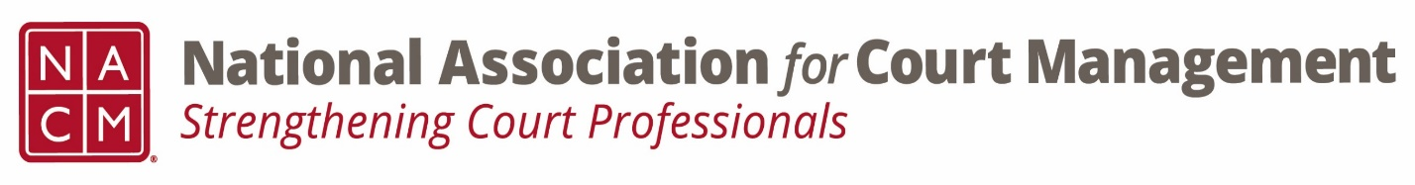
Ethics Subcommittee
Thursday, June 26, 2025
2:00 p.m. Eastern Time
Zoom Link

- Welcome and Introductions of any new participants.
Creadell Webb, Roger Rand, Peter Kiefer, Courtney Whiteside
Call to order 1:09pm

- Approval of the Minutes from April 24, 2025.
Approval

- Governance Committee Call Report
  - Voice of the Profession survey
Get proposed changes to Nicole Garcia and Courtney Whiteside by 7/2/25
  - State of the Profession address
Delivered to Tina for additional comment and finalization
- Committee Reports
  - Conference Development Committee
Minimal discussion in meeting due to conference being inside of a month
  - Communications- Social Media & Website
Change in leadership coming
  - DEI
Last meeting looking at various training topics- hiring autistic talent
Discussion on DEI terminology focused on continuing the work being the focus
  - CORE
Curriculum changes coming soon pending board review
  - Membership- ECP, State Associations, & International
No report
  - Past Presidents
No report

- Old Business
  - Review NACM Model Code of Conduct and the NACM AI Guide for February working meeting on Canon 5
      - Model Code of Conduct
        - Ethics Subcommittee – National Association for Court Management (nacmnet.org)
      - Any final discussion on removing Canon V
      - Agreed with the caveat to revisit at a future date
    - Subcommittee chair interest

- Open discussion/New Business
  - Subcommittee chair selection
      - Erica Schmidt
      - Samantha Wallis
      - Andrea Powers
    - Question of ethics episode being submitted for July 1 deadline

- A Question of Ethics- Suspended
*NOTE* This portion of the meeting will be recorded and shared with the membership.

- Next Meeting- TBD

