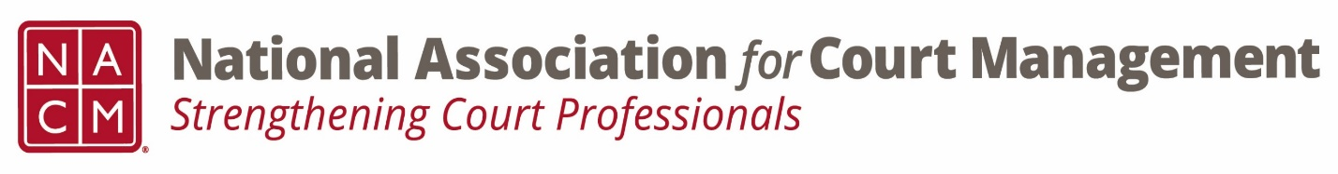

Conference Call of the Ethics Subcommittee

Thursday, January 26, 2023
2:00 p.m. (EDT)
Zoom Meeting ID: 710 387 5466 Passcode: 021675

- Welcome and Introductions of any new participants.
- Approval of the Minutes from October 27, 2022
- Governance Committee Call Report-

- Conference Development Committee Call Report-

- Any other Committee Call Report-
- Open discussion/New Business

- A Question of Ethics- Norman Meyer
*NOTE* This portion of the meeting will be recorded and shared with the membership.

- Next Meeting February 23, 2023.
Volunteer for the February 2023 “Question of Ethics”

