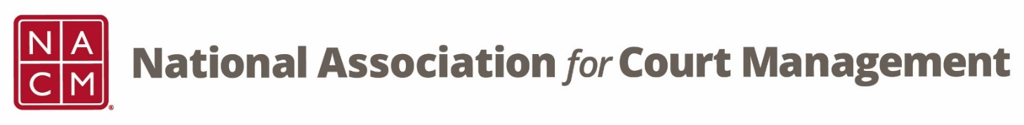

CORE® Committee Meeting
February 22, 3 p.m. ET

Attendees:
Kelly Hutton | Ed McNachtan | Janet Cornell | Richard Lynch
Termica Lucas | Norman Meyer | Kent Pankey | Mallory Minor
Jude Del Preore | Brandon Henson | Rick Pierce | Ellen Haines
Juli Edwards-McDaniel | Tina Mattison

Minutes:
- Previous Meeting Minutes (attachment)
Previous meeting minutes were reviewed, no changes were noted, and will be posted to the website.

- Midyear Conference Check-In
Kelly discussed the midyear conference and asked those that attended in-person or virtually how they thought it went. Those on the call in attendance indicated that the conference went well and that all of the sessions were well attended and received.

- CORE Champion
  - Website
  - Annual Conference
  - Structured Response Tests
  - Next Phase
Kelly provided an update on:
- Website – The CORE® website overhaul is still underway.
- Annual conference - will possibly have 3 CORE® sessions and will provide the final content needed for someone to complete the CORE® Champion Program.
- SRTs – Roughly 20 SRTs have been received since annual. There are new participants in the program but we did receive several from members previously participating.
- Next phase – A small group of the board of directors have been meeting to discuss possibilities for the next phase of the CORE® Champion program and additional ways to promote the CORE® this would include additional webinars, recordings, and sessions with the ability to possibly expand to state/regional associations.

- CORE News – Brandon Kimura
Brandon was not able to attend the meeting, however, he did send Angie a CORE® news update to post regarding sessions at the conference, a quick plug for the CORE® Champion and a brief description of each of the curriculum covered.

- Curriculum Review
  - CORE In Practice – Janet Cornell
  - Public Relations – Dawn Palermo
Janet provided an update on the CORE® in Practice workgroup. The group has decided to add summary content on each of the curriculum. They are still on schedule to complete in time for publication/release at the annual conference.

Dawn was not able to attend the meeting, however, Kelly provided and update regarding the Public Relations workgroup, there is a meeting tomorrow, and the group is also on track to complete the review before the annual conference.

- CTC Conference Submission
Kelly indicate that a group of volunteers met and discussed submitting a proposal to present at CTC. The group decided to submit a proposal on data collection, dashboards and warehouses. The team presenting will be Jeffrey Tsunekawa, Tina Mattison, Roger Rand, and Ellen Haines.

- Strategic Plan
Kelly shared NACM’s strategic plan with the group and highlighted CORE® and education related sections. She reviewed how the current projects apply to these areas. Tina added that the group can use ideas discussed today to start creating/planning items that we can recommend for next year’s strategic plan.

Norman discussed the relaunch of the mentoring program and its alignment with the National Conference of Bankruptcy Clerks’ LEAD Academy. Kelly recommended that Norman may want to partner with the membership committee since they are relaunching the program.

Janet discussed that she would like to see a new roster of tangible items regarding the CORE® or an expansion of the CORE®. She mentioned standalone self-assessments and executive summaries.

Kelly also told the group to let her or any board member know if they have an interest in assisting with any of the goals or items in the strategic plan. She or the other members can point anyone interested in the direction of the group working on that goal/item.

- Other:
None

- Next Meeting(s):
  - March 22, 2023
  - April 26, 2023
  - May 24, 2023
  - June 28, 2023

