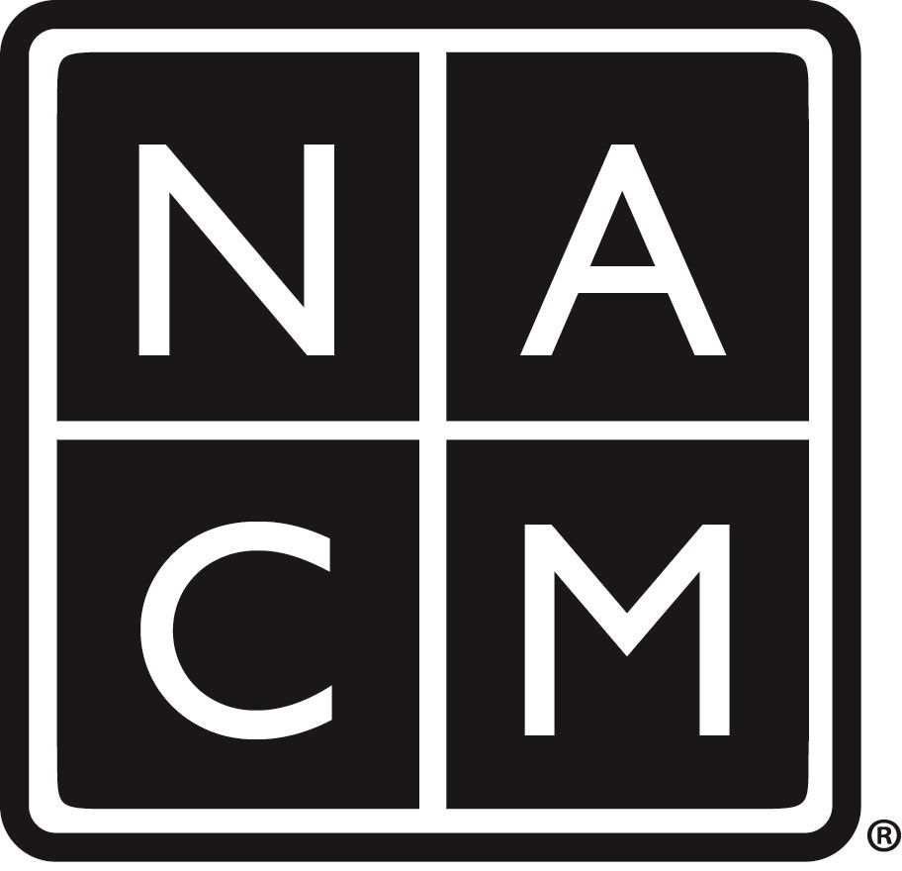

National Association for Court Management
Future Conferences

2019
Midyear Conference  February 10-12, 2019 – Little Rock, AR  Little Rock Marriott  3 Statehouse Plaza, Little Rock AR 72201  (501) 906-4000  Room Rate: $118 per night single/double occupancy + 15%  Cut Off Date: Friday, January 18, 2019  Member Nonmember  On or Before 12/1 $475 early $640 early  12/1 – 1/31 $575 regular $740 regular  2/1- onsite $625 onsite $790 onsite  Group $425/$525 after 12/1 $590/$690 after 12/1  ECP $425/$525 after 12/1  Daily $200 $240 | Annual Conference  July 21-25, 2019 – Las Vegas, NV  The Bellagio  3600 S Las Vegas Blvd., Las Vegas, NV 89109  (702) 693-7111  Room Rate: $165 per night single/double occupancy  $34 resort fee + taxes  Cut-off date: June 29, 2018  Member Nonmember  On or Before 5/1 $615 early $755 early  5/2 – 6/30 $715 regular $855 regular  6/30 - Onsite $785 $925  Group $615/$715 after 5/31 $755/$855 after 5/31  ECP $615/$715 after 5/31  Daily $275 $300
2020
Midyear Conference  February 9-11, 2020 – Charlotte, NC  The Westin Charlotte  601 South College Street, Charlotte NC, 28202  (704) 375-2600  Room Rate: $192 per night single/double occupancy + 15.25%  Cut Off Date: Friday, January 17, 2020 | Annual Conference  July 12-16, 2020 – New Orleans, LA  Hilton New Orleans Riverside  Two Poydras Street, New Orleans, LA 70130  (504) 561-0500  Room Rate: $185 per night single/double occupancy +$3 + 14%  Cut-off date: Friday, June 19, 2020
Check for availability of online registration at www.nacmnet.org

