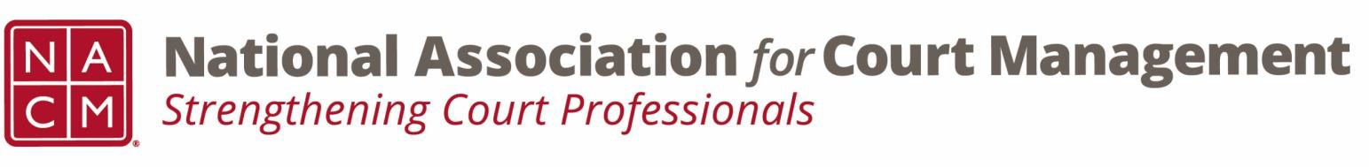

# **Governance Committee Minutes**

**June 4, 2025, 3:00 p.m. Eastern via Zoom**

Zoom link: <https://us06web.zoom.us/j/81227189771?pwd=bRWbW5ruaslCR6VMp5aM1MEXPmXUPP.1>

**Chair:** [Nicole Zoe García](mailto:nicole@nacmnet.org) **Vice Chair**: [Courtney Whiteside](mailto:courtney@nacmnet.org)

[**Committee Page**](https://nacmnet.org/governance-committee/)

**Attendees**: Nicole Garcia, Courtney Whiteside, Tina Mattison, Craig Washburn, Mark Weinberg,   
Kristie Collier, Melinda Brooks, Rick Pierce, Kent Pankey, Rick Pierce, Tammi Asay, Kelly Hutton

1. **Call to Order**12:02 Meeting called to order
2. **Approval of Minutes**No changes or comments. Motion to approve- Kent Pankey, Second Mark Weinberg. The minutes are approved as drafted.
3. **Update on Court Employee Appreciation Week and Toolkit**    
   Tool kit can be found on the website on the Governance page as well as the Publications page. Recognition of Kelsey for her work on the toolkit.
4. **Reports of Sub-Groups**
   1. Ethics Subcommittee – Courtney Whiteside  
      No Canon V: Social Media and AI
   2. State of the Profession Workgroup – Nicole Garcia  
      Completed and submitted final draft to Tina
5. **New Business**
   1. Slideshow for SOP  
      Images needed and volunteers needed. Email Nicole or Tina to participate. Slideshow reference to be sent but can be found on the website with the speech in its entirety. Jude- pictures already collected. Perhaps if there are overflow.
   2. 2025 Voice of the Profession

Annual survey. Need volunteers to review questions for relevance and applicability. Target to send out the week before the conference. Review survey before July 2nd meeting for comment or email Nicole with suggestions. See attachment of survey results sent out with agenda.

1. **NACM Committee Updates**Conference Development- leadership seminar with NASJE on Sunday. Send Kelly, Tina, or Jude to join. Everyone to get an anniversary pin and conference lanyard in attendance.  
   Membership- updated swag on Amazon store  
   Communications- Court Manager coming out soon. Always needing more submissions. New Social Media chair. Submission form to post is available on the website.  
   Nominations- Declaration of candidacy due this Friday.
2. **Adjourn**Motion to adjourn- Courtney Whiteside, Seconded- Rick Pierce and Kristie Collier. Meeting adjourned at 2:26pm