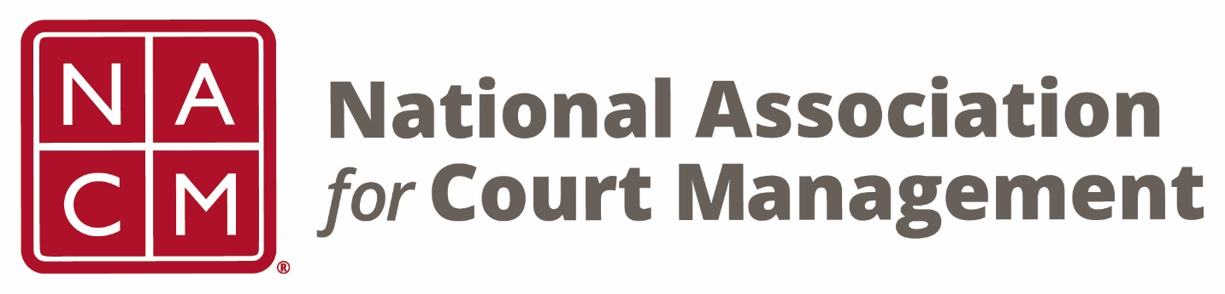

NACM 32nd President
2016-2017

Scott Griffith
Board Accomplishments

- NACM President represented the Association on the CCJ/COSCA National Task Force on Fines, Fees, and Bail Practices.

- Two successful webinars were conducted on Emergency Preparedness and LGBTQ.

- A Domestic Violence Guide for Courts was prepared and released.

- A Joint Conference was conducted with the International Association for Court Administration (IACA).

- NACM President served on American University’s Right to Counsel Initiative. Several Conference sessions grew out of this effort.

- Renewed efforts to formalize NACM’s relationship with partner organizations, particularly NCJFCJ – National Council of Juvenile and Family Court Judges.

- Decision made to roll out at least one CORE® Competency at each Conference.

- Developed processes for the drafting of resolutions and for routine review of the Strategic Plan.

- Membership Brochure, Application and Audit processes all approved.

- Updated NACM/NCSC Master Services Agreement.

