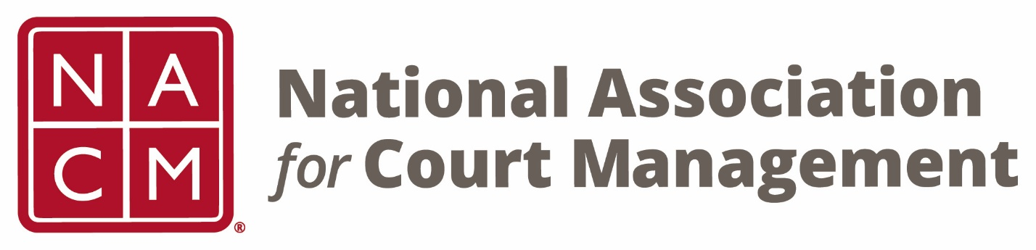

NACM 31st President
2015-2016

Stephanie Hess

Board Accomplishments

- NACM Strategic Plan updated for 2016-2019. New plan established 4 priorities: a) Membership b) Education & Resources c) Advocacy and d) Association Governance and Sustainability

- Tag line changed from Committed to Excellence to Strengthening Court Professionals

- NACM® CORE registered as a trademark under US Serial Number 86568226.

- Resolution approved to support the work of the National Task Force on Fines, Fees, and Bail Practices.

- Adopted Open Door Policy to encourage reporting and investigation of any violations of Bylaws, lawful agreements, rules, or policies.

- Revitalized Mentorship Program

- Guides developed for User Friendly Courts and Electronic Records Retention and Management.

- Updated the Court Administrator Guide.

