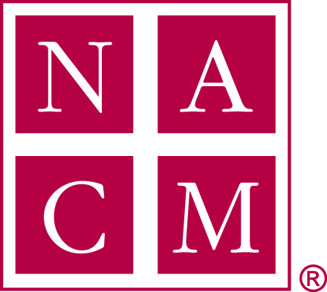
National Association
for Court Management Strengthening Court Professionals

INTERNATIONAL SUBCOMMITTEE MEETING AGENDA
THURSDAY, SEPTEMBER 28, 2017
3:00 P.M. ET

DIAL IN INFORMATION: 1-800-503-2899; PASSCODE: 2591537

- Introductions

- 2017-2018 Committee focus

- Online Community

- Resource document

- International Column – Court Manager

- NCSC Connected International Information

Future Conference Calls: 4th Thursday, every other month, 3:00 p.m. ET (except November)

November 16

January 25

March 22

May 24

July 26

