Model Code of Conduct for
Court Professionals in the State of Nevada

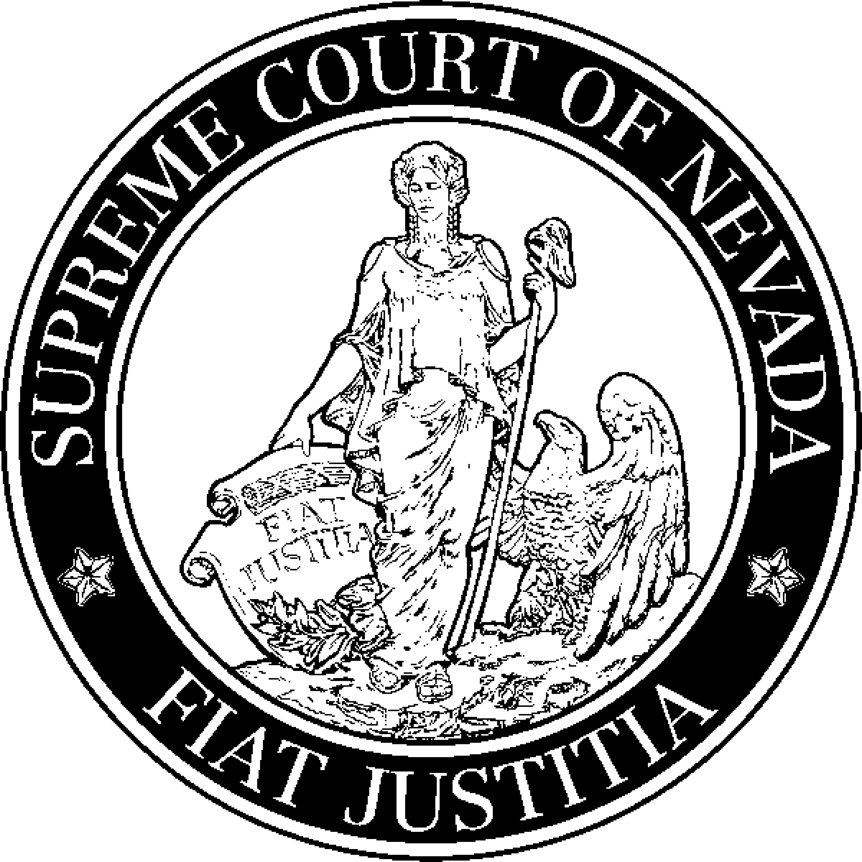

Prepared by:

Judicial Council of the State of Nevada

Court Administration Committee

Model Code of Conduct for
Court Professionals in the State of Nevada

Table of contents
Preface 1
Organization of the Model Code 2
Scope 2
Glossary of Terms 3
CANON 1 – Avoiding Impropriety and the Appearance of Impropriety in All Activities 4
1.1 Performing Court Duties 4
1.2 Avoiding Impropriety 4
1.3 Fairness 4
1.4 Respect for Others 5
1.5 Involvement in Actions Before a Court 5
1.6 Avoiding Privilege 5
1.7 Assisting Litigants 6
CANON 2 – Performing the Duties of Position Impartially and Diligently 8
2.1 Independent Judgment and Conflict of Interest 8
2.2 Personal Relationships 10
2.3 Misconduct of Others 10
2.4 Attempts at Influence 10
2.5 Properly Maintain Records 10
2.6 Confidentiality Requirements 10
2.7 Discretion 11
2.8 Proper Use of Public Resources 11
CANON 3 – Conducting Outside Activities to Minimize the Risk of Conflict with Official Position 12
3.1 Outside Business 12
3.2 Compensation 12
3.3 Gifts, Donations, and Grants 14
3.4 Financial Disclosure 15
CANON 4 – Refraining from Inappropriate Political Activity 16
4.1 Refraining from Inappropriate Political Activity 16

Model Code of Conduct for
Court Professionals in the State of Nevada
(Revision Date – June 2020)

Preface
Service to the judicial branch inherently involves a public trust.

The foundation of our society rests, in part, on the ability of its citizens to wisely judge the value of our courts and to appreciate the integrity of our judiciary as a fundamental, coequal branch of government. Court professionals who work for the judicial branch are faithful to its values and are accountable to this trust.
This Model Code of Conduct applies to all employees of the Judicial Branch in the State
of Nevada except the justices, and judicial officers. Contractors and other non-employees who serve the judiciary are not covered by this Code, but appointing authorities may impose these or similar ethical standards on such non-employees, as deemed appropriate.
The standards contained within this Code do not preclude the adoption of more rigorous standards by law, court order, or local rule. Violations of this Code may be enforced within the local jurisdiction and in the same manner as violations of local personnel rules that apply to judicial employees. In certain cases, it is understood that judicial employees may be bound by local court and/or local government personnel rules and procedures and each chief judge or appointing authority may have to ascertain the prioritization of this Code when or if certain conflicts arise between the rules of the local government and this Code.
The original Model Code was drafted by the Court Administration Committee and subsequently approved by the Judicial Council for the State of Nevada in March 2004.
In 2013, the Court Administration Committee updated and reorganized the current model code to include social media and additions from the National Association for Court Management (NACM). The current effort (2020) compares the 2013 model to a 2018 update developed by the NACM Ethics Subcommittee.

Organization of the Model Code
The Code is organized into four canons.

Canon One (“Avoiding Impropriety and the Appearance of Impropriety in All Activities”) addresses performing court duties, avoiding impropriety, being fair, respecting others, being involved in actions before a court, avoiding privilege, and assisting litigants.

Canon Two (“Performing the Duties of Position Impartially and Diligently”) addresses independent judgment, personal relationships, misconduct reports, attempts at influence, proper record maintenance, legal requirements, discretion, and proper use of public resources.

Canon Three (“Conducting Outside Activities to Minimize the Risk of Conflict with Official Position”) addresses outside business, compensation and post-employment restrictions, gifts, and financial disclosure.

Canon Four (“Refraining from Inappropriate Political Activity”) discusses appropriate political activity of court professionals.

Scope
The Model Code is intended to apply to all court professionals who work for the courts. That includes full-time, part-time, and temporary employees; interns; externs; and individuals performing essential court functions who are either paid by, or under contract to, an outside agency or entity.

The Model Code is not intended to replace other professional codes to which some court professionals already adhere; employment agreements or union contracts; or policies, procedures, and personnel rules. The Code is a supplement to other rules, and is intended to live outside the rules, even if its substance is replicated in policy, rules, and procedures. The Model Code assumes that obedience to the law is a prerequisite for commitment to the Canons; therefore, obeying the law or court rules is not incorporated into the Code.

Glossary of Terms
Appointing Authority is normally a judge or appointed designee, such as a Court Administrator, County Clerk, or Chief Deputy Clerk, based on the court’s organizational reporting structure and reporting circumstances necessary to achieve the Model Code’s underlying intent: full disclosure and appropriate notification.
Canon is a fundamental principle governing the conduct of judicial employees. The broad statement of principle appearing before each section of the Code, and all subsections are the canons.
Model Code is the abbreviated name for the Model Code of Conduct for Court Professionals in the State of Nevada; may also be referred to as the Code.
Court professional is any person employed in support of the Judicial Branch in the State of Nevada who directly affects the operation of the judiciary. Court professionals may work under the direct or indirect supervision of the judge, court administrator, or elected or appointed clerk of the court.
Personal staff means any employee or person who is appointed by and reports directly to the judge (e.g., personal staff may include judicial assistants and law clerks).

Social media means any activity on the Internet that involves posting by the judicial employee, such as blogging; posting comments to any website; posting photos, posting video, other graphics, or multimedia materials; posting documents or links; posting status updates, comments, or links; posting materials or links, or sharing or participating in any other way on a social networking site like Facebook; micro-blogging, for example through Twitter; contributing to a wiki; and so on. These guidelines do not target messages sent through email or a social networking site directed to individuals or to small groups of personal friends, except as it relates to confidentiality.

CANON 1

Avoiding Impropriety and the Appearance of Impropriety
in All Activities
1.1 Performing Court Duties
A court professional faithfully carries out all appropriately assigned duties, striving at all times to perform the work diligently, efficiently, equitably, thoroughly, courteously, honestly, openly, and within the scope of the court professional’s authority.
A court professional shall respect and comply with the law and these canons. A court professional shall maintain competence in the knowledge, skills, and abilities applicable to the employee’s position in the court.
A court professional shall uphold the integrity and independence of the judiciary. An independent and honorable judiciary is indispensable to justice in our society. A court professional shall personally observe high standards of conduct so that the integrity and independence of the judiciary are preserved and the judicial employee’s office reflects a devotion to serving the public. Court professionals shall require adherence to such standards by personnel subject to their direction and control. The provisions of this Code shall be construed and applied to further these objectives. The standards of this Code shall not affect or preclude other more stringent standards required by law, by court order, or by an appointing authority. Court professionals shall encourage respect for the law and the administration of justice.
1.2 Avoiding Impropriety
A court professional avoids both impropriety and the appearance of impropriety. A court professional shall not engage in any activity that would put into question the propriety of carrying out the duties of the office. This includes avoiding improper influences from business, family, position, party, or person as well as avoiding activities that would impugn the dignity of the court. A court professional shall not lend the prestige of the office to advance or to appear to advance the private interests of themselves or others. A court professional shall not use public office for private gain, and shall refrain from publicly endorsing any product or service in their official capacity, including through social media.
1.3 Fairness
The court professional makes the court accessible and conducts his or her work without bias or prejudice.

1.4 Respect for Others
A court professional treats litigants, co-workers, and all others interacting with the court with patience, dignity, respect, and courtesy.
1.5 Involvement in Actions Before a Court (Note, there are two 1.5 versions for this section. Each court must identify which version they are going to use and remove this note and the other version.)
A court professional notifies the appropriate authority whenever he or she is arrested, named as a party, or is otherwise formally involved in any action pending in any court.
A court professional notifies the appropriate authority whenever the following people are named as a party or otherwise involved in any action pending in any Nevada court:
A. A member of the court professional’s immediate family; or
B. An individual who has a relationship with the court professional, such that disclosure would be deemed warranted by a reasonable, prudent court professional.
1.5 Involvement in Actions Before a Court (Note, there are two version for this section. Each court must identify which version they are going to use and remove this note and the other version.)
A court professional notifies the appropriate authority whenever he or she is arrested, named as a party, or is otherwise formally involved in any action pending in any court.
A court professional notifies the appropriate authority whenever the following people are named as a party or otherwise involved in any action pending in any ______ County court:
A. A member of the court professional’s immediate family; or
B. An individual who has a relationship with the court professional, such that disclosure would be deemed warranted by a reasonable, prudent court professional.
1.6 Avoiding Privilege
A court professional uses his or her official position solely for its intended purpose.
A court professional does not use his or her position to secure unwarranted privileges or exemptions for oneself or others.
A court professional does not dispense special favors to anyone, whether or not he or she was offered remuneration.
1.7 Assisting Litigants
A court professional is responsive to inquiries regarding standard court procedures but does not give legal advice unless required as part of one’s official position.
Nevada Supreme Court Rule 44 authorizes court professionals, including county clerks and their deputies working for courts in their ex-officio capacity, to provide information to pro per litigants under certain circumstances.
Court professionals who are employed by a governmental entity and working within a governmental environment and who are not supervised by a licensed Nevada attorney are authorized to do the following:
- Encourage persons to obtain legal advice from a licensed Nevada attorney outside of the qualifying public entity;
- Provide information about available pro bono, free/low cost civil legal services, legal aid programs and lawyer referral services;
- Provide information about available forms/pleadings/instructions without providing advice or recommendations as to any specific course of action;
- Engage in oral communications to assist persons in the completion of blanks on forms;
- Provide orally or in writing definitions of legal terminology from widely-accepted legal dictionaries or other dictionaries without advising whether or not a particular definition is applicable to the situation of the requesting person;
- Provide orally or in writing citations, constitutions, statutes, administrative/court rules, and case law without providing legal research as defined below or advising whether or not a particular provision is applicable to the situation of the requesting person;
- Provide information on docketed cases;
- Provide general information about court process, procedure and practice;
- Provide information about mediation, parenting courses and/or courses for children of divorcing parents;
- Provide orally or in writing information on local court rules and/or administrative orders; and
- Provide general information about community resources.
No person or entity described in this rule and not licensed to practice law in Nevada or being supervised by a Nevada licensed attorney may do any of the following:
- Provide orally or in writing any interpretation by application of the following to specific facts: legal terminology, constitution, statutes, or administrative/court rules or case law;
- Provide orally or in writing information that must be kept confidential by statute, administrative/court rule or case law;
- Create content on documents not provided by self-represented litigants;
- Perform direct legal research for any litigant by applying the law to specific facts, expressing an opinion regarding the applicability of any constitutional provisions, statutes, administrative/court rules or case law to the particular circumstances of the requesting person; or
- Lead persons to believe they are the legal representatives of anyone in any capacity or induce the public to rely on them for legal advice.
Canon 2
Performing the Duties of Position Impartially and DiligentlY
2.1 Independent Judgment and Conflict of Interest
A court professional avoids relationships that would impair one’s impartiality and independent judgment.
A court professional is vigilant concerning conflicts of interest and ensures that outside interests are never so extensive or of such a nature as to impair one’s ability to perform court duties.
A conflict of interest arises when a judicial employee knows that he or she (or the spouse, minor child residing in the judicial employee’s household, or other close relative of the judicial employee) might be so personally or financially affected by a matter that a reasonable person with knowledge of the relevant facts would question the judicial employee’s ability to properly perform official duties in an impartial manner.
(1) Certain court professionals, because of their direct relationship to a judge or the nature of their duties, are subject to the following restrictions:
(a) A staff attorney or law clerk shall not perform any official duties in any matter with respect to which such person knows that:
(i) He or she has a personal bias or prejudice concerning a party, or personal knowledge of disputed evidentiary facts concerning the proceeding;
(ii) He or she served as an attorney or staff attorney in the matter in controversy, or an attorney with whom he or she previously practiced law had served (during such association) as a lawyer concerning the matter, or he, she, or such lawyer has been a material witness;
(iii) He or she, individually or as a fiduciary, or the spouse or minor child residing in his or her household, has a financial interest in the subject matter in controversy or is a party to the proceeding;

(iv) He or she, a spouse, or a person related either within the third degree of relationship, or the spouse of such person (A) is a party to the proceeding, or an officer, director, or trustee of a party; (B) is acting as a lawyer in the proceeding; (C) has an interest that could be substantially affected by the outcome of the proceeding; or (D) is likely to be a material witness in the proceeding;
(v) He or she has served in governmental employment and in such capacity participated as counsel, advisor, or material witness concerning the proceeding or has expressed an opinion concerning the merits of the particular case in controversy.
(b) A court professional whose assignment with a particular judge is reasonably perceived as being comparable to a member of the judge’s personal staff, shall not perform any official duties in any matter with respect to which personal staff knows that he or she, a spouse, or a person related to either within the third degree of relationship, or the spouse of such person:
(i) Is a party to the proceeding, or an officer, director, or trustee of a party;
(ii) Is acting as a lawyer in the proceeding;
(iii) Has an interest that could be substantially affected by the outcome of the proceeding; or
(iv) Is likely to be a material witness in the proceeding; provided, however that when the foregoing restriction presents undue hardship, the judge may authorize the judicial employee to participate in the matter if no reasonable alternative exists and adequate safeguards are in place to ensure that official duties are properly performed. In the event the judicial employee possesses any of the foregoing characteristics and so advises the judge, the judge shall also consider whether the Revised Nevada Code of Judicial Conduct may require the judge to recuse.
(c) A probation or pretrial services officer who is a judicial employee shall not perform any official duties in any matter with respect to which the probation or pretrial services officer knows that:
(i) He or she has a personal bias or prejudice concerning a party;
(ii) He or she is related within the third degree of relationship to a party to the proceeding, or to an officer, director, or trustee of a party, or to a lawyer in the proceeding;
(iii) He or she, or a relative within the third degree of relationship, has an interest that could be substantially affected by the outcome of the proceeding.
2.2 Personal Relationships
A court professional recruits, selects, and advances personnel based on demonstrated knowledge, skills, abilities, and bona fide work-related factors, not on favoritism.
A court professional avoids appointing, assigning, or directly supervising a family member, or attempting to influence the employment or advancement of a family member.
When circumstances dictate that one must work directly with a family member, a court professional reports the circumstances to an appropriate authority, regularly assesses the situation, and takes remedial action at the earliest time practicable.
2.3 Misconduct of Others
Court professionals expect their fellow professionals to abide by the Canons set out in this code.
A court professional reports to the appropriate authority the behavior of any court professional who violates this Code including, but not limited to, potential conflicts of interest involving one’s duties and attempts to inappropriately influence one in performing one’s duties.
2.4 Attempts at Influence
A court professional immediately reports to the appropriate authority any attempt to compel one to violate these Canons.
2.5 Properly Maintain Records
A court professional does not destroy, alter, falsify, mutilate, backdate, or fail to make required entries on any records within the court’s control unless authorized by statute, court rule, or administrative policy.
2.6 Confidentiality Requirements
A court professional maintains the legally required confidentialities of the court, not disclosing confidential information to any unauthorized person, for any purpose.
A court professional properly provides confidential information that is available to specific individuals authorized to receive such by reason of statute, court rule, or administrative policy.
Court professionals shall take special care to preserve the confidentiality of the court’s work product. Work product includes, but is not limited to, legal memoranda, preliminary dispositions, and discussions of pending court matters by a judge, law clerk, clerk’s office staff attorney, or court employee. Work product also includes legal research performed by the law library staff for the court, and administrative matters such as preliminary budget discussions. Any work product of the court that is not a matter of public record is confidential.
- The work product of a former employee remains confidential. While a staff attorney may use a legal memorandum written by him or her as a writing sample, an opinion or an order, either in draft or final form, may not be used as a writing sample or claimed by a former employee as his or her work product. A law clerk must first obtain the approval of his or her judge before using any legal memorandum as a writing sample.
- A law clerk or staff attorney shall not disclose to persons who are not employees of the court the extent of his or her involvement in the decision-making process of any specific matter or proceeding.
- Court professionals refrain from use of any social media to post confidential information including but not limited to the likely outcome of a pending case, confidential case processing procedures, and other non-public information, and abide by any local court policy regarding social media.
2.7 Discretion
A court professional avoids making public comment on the merits of a pending or impending action. A court professional respects the personal lives of litigants, the public, applicants, and employees; disregards information that legally cannot or should not otherwise be considered; uses good judgment in weighing the credibility of Internet information; is cautious about verifying identities; and uses the Internet wisely.
This proscription does not extend to public statements made in the course of official duties or to the explanation of court procedures.
2.8 Proper Use of Public Resources
A court professional uses the resources, property, and funds under his or her official control judiciously and solely in accordance with prescribed procedures.
CANON 3
Conducting Outside Activities to Minimize the Risk of Conflict with Official Position
3.1 Outside Business
The court is a court professional’s primary employment. A court professional avoids outside activities, including outside employment or concurrent business activities, that reflect negatively on the judicial branch and one’s own professionalism.
A court professional notifies the appropriate authority prior to accepting work or engaging in business outside of his or her court duties.
A court professional does not request or accept any compensation or fee beyond that received from their employer for work done in the court of their public employment.
Following notification and approval, if required by the appropriate authority, court professionals may engage in outside employment as long as it does not conflict with the performance of their official responsibilities, the administration of the court, or reflect adversely on the court or the judicial branch.
Subject to the foregoing standards and the other provisions of this Code, a court professional may engage in such activities as civic, charitable, religious, professional, educational, cultural, avocational, social, fraternal, and recreational activities, and may speak, write, lecture, and teach. Caution should be used with regard to social media and these activities. If such outside activities concern the law, the legal system, or the administration of justice, the court professional shall first consult with the appropriate authority to determine whether the proposed activities are consistent with the foregoing standards and the other provisions of this Code.
3.2 Compensation
During one’s employment with a court, a court professional does not represent a commercial interest of, or do business with, that same court unless both the employment and commercial interest are fully disclosed to and approved by the court’s appropriate management authority.
However, court reporters are not prohibited from providing reporting services for compensation to the extent provided by statute and by the court. A member of the judge’s personal staff shall consult with the appointing judge concerning any financial and business activities that fail to conform to the foregoing standards or that the judge concludes may otherwise give rise to an appearance of impropriety.
During judicial employment, a law clerk or staff attorney may seek and obtain employment to commence after the completion of the judicial employment. However, the law clerk or staff attorney shall first consult with the appointing authority and observe any restrictions imposed by the appointing authority. If any law firm, lawyer, or entity with whom a law clerk or staff attorney has been employed or is seeking or has obtained future employment appears in any matter pending before the appointing authority, the law clerk or staff attorney shall promptly bring this fact to the attention of the appointing authority.
A. Practice of Law. A full-time judicial employee who is otherwise qualified to practice law in the State of Nevada shall not engage in the practice of law except that
a judicial employee may act pro se and may perform routine legal work incident to the management of the personal affairs of the judicial employee or a member of the judicial employee’s family, so long as such pro se or family legal work does not present an appearance of impropriety, does not take place while on duty or in the judicial employee’s workplace, and does not interfere with the judicial employee’s primary responsibility to the office in which the judicial employee serves, and further provided that:
(1) In the case of pro se legal work, such work is done without compensation (other than such compensation as may be allowed by statute or court rule in probate proceedings); and
(2) In the case of family legal work, such work is done without compensation (other than such compensation as may be allowed by statute or court rule in probate proceedings) and does not involve the entry of an appearance in court.
Court professionals may also serve as uncompensated mediators or arbitrators for nonprofit organizations, subject to the provisions of this Code.
A court professional shall ascertain any limitations imposed by the appointing judge or the court on which the appointing judge serves concerning the practice of law by a former judicial employee before the judge or the court and shall observe such limitations after leaving such employment.
B. Compensation and Reimbursement. A court professional may receive compensation and reimbursement of expenses for outside activities provided that receipt of such compensation and reimbursement is not prohibited or restricted by this Code, and other applicable law, provided that the source or amount of such payments does not influence or give the appearance of influencing the judicial employee in the performance of official duties or otherwise give the appearance of impropriety.
Notwithstanding the above, a judicial employee shall not receive any salary, or any supplementation of salary, as compensation for official government services from any source other than by a governmental entity provided, however, that court reporters are not prohibited from receiving compensation for reporting services to the extent permitted by statute and by the court.
3.3 Gifts, Donations, and Grants
A court professional does not solicit, accept, agree to accept, or dispense any gift, favor, or loan either for oneself or on behalf of another, when such an act is based upon any understanding, either explicit or implicit, that would influence an official action of the court.
When engaged in or assisting with fundraising, advocating for community or private-sector support, or serving on the board of a third-party fiscal agent or committee, a court professional avoids any implication that contributions would enhance a contributor’s standing or influence with the court or its judges.
A court professional may solicit funds in connection with outside activities, subject to the following limitations:
- A court professional shall not use or permit the use of the prestige of the office in the solicitation of funds.
- A court professional shall not solicit subordinates to contribute funds to any such activity but may provide information to them about a general fund-raising campaign. A member of the judge’s personal staff shall not solicit any court personnel to contribute funds to any such activity under circumstances where the staff member’s close relationship to the judge could reasonably be construed to give undue weight to the solicitation.
- A court professional shall not solicit or accept funds from lawyers or other persons likely to come before the court professional or the court or office the court professional serves, except as incident to a general fund-raising activity. Care should be used also with social media and fundraising in this manner.
- A court professional shall not solicit or accept a gift from anyone seeking official action from or doing business with the court or other entity served by the court professional, or from anyone whose interests may be substantially affected by the performance or nonperformance of official duties, except that a court professional may accept a gift as permitted by local rule or procedure. A court professional shall endeavor to prevent a member of a court professional’s family residing in the household from soliciting or accepting any such gift except to the extent that a court professional would be permitted to do so by local rule or procedure.
- A court professional shall report the value of gifts to the extent a report is required by other applicable law, local rule, or procedure.
3.4 Financial Disclosure
In addition to complying with all requirements by law, rule or regulation, a court professional discloses all financial interests and dealings that might create the appearance of impropriety.

CANON 4
REFRAINING FROM INAPPROPRIATE POLITICAL ACTIVITY
4.1 Refraining from Inappropriate Political Activity
A court professional retains his or her right to vote and exercises that right as a part of citizenship.
A court professional engages in political activity strictly as a private citizen and only in accordance with Federal law, state law, local court rule, and policy of the appropriate governing authority.
Court professionals may engage in political activity if such activity does not tend to reflect adversely on the dignity or the impartiality of the court or office and does not interfere with the proper performance of official duties. Court professionals are discouraged from political activity directly related to judicial campaigns. A court professional may not engage in such activity while on duty or in the court professional’s workplace and may not use any court or local government resources in connection with such activity. Engaging in any political activity is done strictly as a private citizen and only in accordance with state law or court rules. A court professional participates in political activity only during non-court hours, using only non-court resources.
A court professional does not use his or her position or title within the court system to influence others.
Unless one is elected to their court position, a court professional takes an unpaid leave of absence upon declaring one’s intent to run for office.
If elected to an office, a court professional resigns his or her position with the court prior to assuming the elected office, unless holding that elected office clearly neither poses a conflict of interest nor interferes with one’s ability to perform his or her court duties.
Caution is urged with regard to the use of social media and political activity. Court professionals should consider impacts related to all canons with regard to social media and political activities.

Justices and Judicial Officers in the State of Nevada are covered under the Nevada Code of Judicial Conduct.

