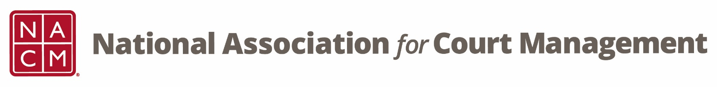

NACM MEMBERSHIP SERVICES COMMITTEE MEETING
Thursday, January 18, 2018 @ 2:00 PM Eastern Time
Via telephone conference: 800-503-2899; Access code: 2591537

- Call to Order – The meeting was called to order at 2:02 pm EST.
- Welcome and Roll Call attendance: Jeff Chapple, Sarah Couture, Scott Griffith, Greg Lambard, Leesa McNeil, Janet Reid, Jeffrey Tsunekawa and Mark Weinberg.

- 2017-2018 Strategic Initiatives

  - Enhance/Increase Membership – After reviewing the current membership map, membership has not changed much over time. The LinkedIn campaign is reaching a lot of individuals but not resulting in new members. We’ve recently started reaching out to specific states with low membership numbers. Leesa suggested that retirees be an area to look at in terms of outreach. Sarah suggested targeting the new COSCA members. Jeff suggested a non-member engagement event at a future conference.
  - Demographic Information – We need to review the data we are currently collecting and come up with useful ideas on how to best use it. What are other organizations doing? We need to find ways to encourage people to update their profiles when they renew their memberships.
  - Dual Membership Agreements – Still a work in progress, but mentioned for people’s awareness.

- ECP Mid-Year Needs and Promotions – Will be executing a scavenger hunt with 11 questions at the midyear conference. Also doing a gummy bear jar where each guess costs $1.00.
- Around NACM – Midyear conference is sold out. Many sessions will be live streamed. Board candidacy and nominations have been posted.
- Next teleconference: Third Thursday of the Month, February 22, 2018 2:00 PM EST
- Adjourn

