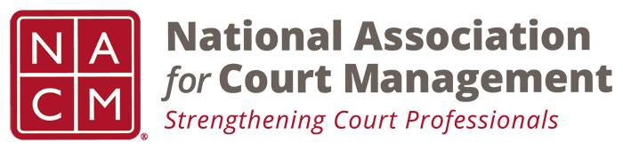

NACM MEMBERSHIP SERVICES COMMITTEE MEETING
Tuesday, January 8, 2019, 11AM ET
+1 (872) 240-3412 Access Code: 922-550-533
https://global.gotomeeting.com/join/922550533

Call to Order Michelle Dunivan
Welcome and Roll Call Michelle Dunivan
Recruitment and new member subcommittee Randall Soderquist
Promotional Video Michelle Dunivan
State Association Agreements Jeff Chapple
Membership Appreciation Jeffrey Tsunekawa
Scholarships and Awards review Jeffrey Tsunekawa
Subcommittees:
- State Associations TJ BeMent
- International Committee Michele Oken
- ECP Angie VanSchoick
New Business
Adjourn

Meeting Schedule
  - February 5, 2019
  - March 12, 2019
  - April 9, 2019
  - May 7, 2019
  - June 11, 2019
  - July 18, 2019- At Annual Conference

