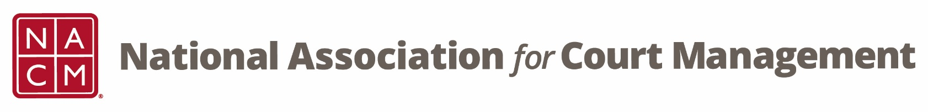

NACM MEMBERSHIP SERVICES COMMITTEE MEETING
Thursday, March 15, 2018 @ 2:00 PM Eastern Time
Via telephone conference: 800-503-2899; Access code: 2591537

- Call to Order- Jeffrey Tsunekawa called the meeting to order at 2:05pm EST
- Welcome and Roll Call attendance: Jeff Chapple, Sarah Couture, Rhoda Jones, Leesa McNeil, Janet Reid, Tanya Rivero, Karl Thoennes, Jeffrey Tsunekawa and Mark Weinberg.

- Monthly Reports – Presently, there are a number of reports on the members only page, and many of them go back many years, even as far as 2012. The committee was asked whether they felt that all of the different reports were still needed or even useful. After a lot of discussion, there was agreement that much of the data could be merged into one report, and to not post previous years reports. The old report information has not been used that anyone was aware of. Janet will work on a new report and work with Jeff and Jeffrey on finalizing it.

- New Member Packet – It is still current practice to assemble a bulky packet and mail it to new members. Its contents include: welcome letter; login credentials; current Board of Directors; and future conferences. The committee was asked if they would be supportive of transitioning to an electronic packet. After much discussion, the committee agreed that having something tangible provided is still a crucial part of welcoming a new member, even it was just a welcome letter. Janet will work with Jeff and Jeffrey on developing the welcome letter and will present it at the next meeting.
- Next teleconference: Third Thursday of the Month, April 19, 2018 2:00 PM EST
- Adjourn

