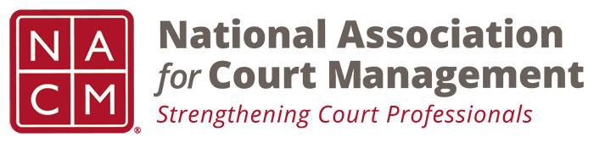

NACM MEMBERSHIP SERVICES COMMITTEE MEETING
Tuesday, March 5, 2019, 11AM ET
+1 (872) 240-3412 Access Code: 922-550-533
https://global.gotomeeting.com/join/922550533

Call to Order Michelle Dunivan
Welcome and Roll Call Michelle Dunivan

- Amanda Leazer
- Michele Oken
- Angie VanShoick
- Alyce Roberts
- Randy Short
- Mark Weinberg
- Renee Danser
- Rick Pierce
- Jeffrey Tsunekawa
- Kathy Griffin
Subcommittees:
- State Associations TJ BeMent
- International Committee Michele Oken
  - IACA revised website and membership structure; reviewing dual membership agreement with NACM as a result of their new dues structure; contracting with NCSC for help with budgeting and finance; conducted a survey similar to the NACM international survey.
  - NACM survey will be in the next Court Express; Norman Meyer suggested providing a brief article to further market the survey
  - Jeff Apperson of NCSC’s International programs suggests that the NACM International subcommittee meet with IACA to discuss joint efforts. NACM may provide association-level mentorship to IACA.
- ECP Angie VanSchoick
  - With the next call, ECP will begin organizing for the Annual Welcome Reception, and charity.
  - Also considering scavenger hunt
  - Great turn out for the Midyear ECP reception
  - May include a mentorship mixer
  - Michele Oken felt this would be a great opportunity for first timers. Could also find a way to have groups that met up and worked together to create a team environment.
  - Kathy Griffin mentioned that the first timers and ECP reception already have a lot of past presidents, as they are formally invited.
  - Mark Weinberg cautioned against confusing mentorship with a conference guide, as mentorship is a formal program that should be long term.
  - Janet Reid also mentioned that mentoring is a member benefit, whereas the receptions are open to non-members as well.
Recruitment and new member subcommittee Randall Soderquist
- Update indicated that scripts will be available for the April meeting for review.
Regional Coordinators Michelle Dunivan
- Randy Short felt this would be a great idea, especially for areas like the Midwest that are relatively isolated compared to the coastal states.
- Mark Weinberg suggested a combination of regional and state coordinators, depending on the size of the existing membership, and geography. Some have enough membership to warrant their own region.
Membership Benefits write up Michelle Dunivan
- Draft provided as an attachment
- Renee Danser asked what survey results we would provide, and cautioned to clarify that the results would be de-identified; still, anything that may help promote the organization, or provide a hyperlink to justification for dues payment would be beneficial
- Rick Pierce warned there may be some disagreement with the last item regarding advocacy, as our member surveys show that people have very different ideas about the role of NACM in advocating for the profession; a disclaimer may address this issue.
- Michelle Dunivan will complete the proposal and present at the next board meeting.
Career Opportunity Conference Event Michelle Dunivan
- Rick Pierce stated that this could be a great opportunity to enhance networking and professional outreach.
- Michele Oken asked if this would be available during the Annual Conference, and cautioned against Sunday when we don’t have the largest attendance; maybe could do this at the same time as the vendor exhibit, or if the vendor exhibit is limited, use the extra time for this event.
Lapsed Member Article Michelle Dunivan
- Mark Weinberg noted that the Regional Coordinators could facilitate some of the ideas from the article.
- Renee Danser noted that NACM hasn’t yet taken advantage of this opportunity; appears to be minimal effort for potential large pay off, especially if we could use iContact to manage.
New Business
Adjourn

Meeting Schedule
  - April 9, 2019
  - May 7, 2019
  - June 11, 2019
  - July 18, 2019- At Annual Conference

