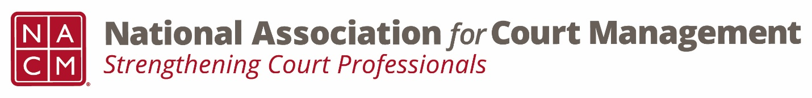

NACM Membership Committee
The NACM President will appoint a member of the Board to serve as chairperson of this committee and its other regular committee members. The committee chairperson will appoint other committee members and subcommittee chairpersons who will work toward the fulfillment of committee goals.

Responsibilities and Role:

- Actively pursue new and non-renewing members. This effort should be supported and supplemented by all officers, directors and members. An incentive plan may be proposed and adopted to encourage this endeavor.
- Respond to all inquiries to the Association concerning membership.
- Provide a wide range of relevant and beneficial membership services.
- Solicit and select the following NACM awards, scholarships and grants:
  - Justice Achievement Award – No more than one award should be given each year. No more than two honorable mention awards may be given each year. This award is designed to recognize courts and court-related organizations for meritorious projects that enhance the administration of justice. The award honors exemplary accomplishments by courts or court-related agencies and organizations. This award may be awarded yearly at the annual conference. If there are no suitable projects nominated, the award will not be presented.
  - Award of Merit – Recipient(s), be it an individual or an organization that has contributed significantly to the field of court administration. One Award of Merit may be given each year. If there are no suitable nominees for this award, the award will not be presented.
  - Graduate Studies Scholarship – Promote the court management profession by recognizing those students who are working towards a graduate level degree to increase their knowledge, skills and abilities in the field of court administration.
  - Edward C. Gallas Award – The Edward C. Gallas Award may be awarded for tuition assistance to one NACM member to attend Phase II, Phase III, or Phase IV of the ICM Fellows Program (formerly known as the Court Executive Development Program). Only those who have been admitted to the upcoming ICM Fellows Phase II class are eligible to apply.
  - NACM ICM Scholarship – NACM may award an Institute for Court Management (ICM) Scholarship in the amount of $1,500 for tuition assistance for one NACM member to attend the Distance Learning, Residential, Court Project, and/or Presentation and Graduation Phases of the ICM Fellows Program (formerly known as the Court Executive Development Program) of the National Center for State Courts (NCSC) Institute for Court Management (ICM). Only those who have been admitted to the upcoming ICM Fellows Distance Learning class are eligible to apply.
  - Conference Scholarship – NACM may award conference scholarships for the Annual Conference. The scholarship recipients will be reimbursed for the conference registration fee as well as costs associated with conference travel, lodging, and meals (not provided by the conference), not to exceed $2,000. Applicants may also request a scholarship to cover a portion of the conference registration fee and travel costs if only partial funds are available.
  - ECP Award – Presented at the annual conference, this award may be presented annually to recognize distinguished service and outstanding contributions to the profession of court administration and the judicial system by an early career professional.
  - Perkins Award – Presented at the annual conference, this award is given to an individual who consistently goes above and beyond the call of duty to make behind-the-scenes contributions to the field of court administration, the court in which he or she works, and ultimately to the public.
- Consult and advise the President concerning the awarding of memberships under the purpose and criteria of the Membership Donation Program.
- Identify states and regions which do not have court management associations; develop strategies for development of new associations.
- Welcome new members and contact purged members with personal contact from a committee member.
- Update list of working groups or subcommittees to be included on Committee Service Form.
- Work with Association Services to order and maintain inventory memorabilia for membership.
- Periodically review and update Membership Profile Form which is included in the membership renewal packet.
- Accomplish any additional objectives as set forth in the Strategic Plan.
- Develop materials which will fully explain the personal and professional benefits of membership, such as the Membership Application form in Appendix.

