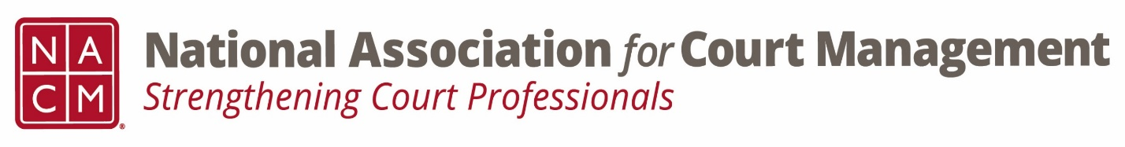

Conference Call of the Ethics Subcommittee

Thursday, August 25, 2022
2:00 p.m. (EDT)
Zoom Meeting ID: 710 387 5466 Passcode: 021675

REMINDER. CUT 15 MINUTES SHORT- DEI MEETING

- Welcome and Introductions of any new participants
- Approval of the Minutes from June 23, 2022
- Governance Committee Call Report-
5 resolutions received, coming subcommittee. By law changes coming, processes being reviewed. Voice and state of the profession work.

- Education Committee Call Report-
“CORE and Conference Development” as two standing committees. Expanding CORE Champion. Curriculum reviews scheduled.

- Any other Committee Call Report
- Any conference discussion needed

- A Question of Ethics- Court Rule and Procedures vs Technological Innovation (Attachments A & B)
*NOTE* This portion of the meeting will be recorded and shared with the membership.

- Next Meeting September 22, 2022.
Karl Thoennes to present the question of ethics topic

