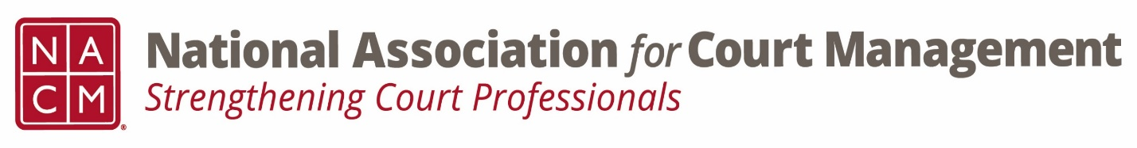

Conference Call of the Ethics Subcommittee

Thursday, October 27, 2022
2:00 p.m. (EDT)
Zoom Meeting ID: 710 387 5466 Passcode: 021675

- Welcome and Introductions of any new participants
- Approval of the Minutes from September 24, 2022 – There are no minutes.
- Governance Committee Call Report- 5 resolutions posted on 10/25- have until 11/25 for comment. Operations changes for committees- get in touch with Brandon.

- Conference Development Committee Call Report- Proposals received and are under review. Request for participation with proposal review.

- Any other Committee Call Report- ECP shared interest group- Katie career learning plans- Dec 14 and Aretha- Evaluations from a non-leadership perspective

- Open discussion/New Business- Peter August question of ethics on google drive is up for review- comment be week’s end or will be posted next week; Norman nominated TJ Bement to do voice overs for the cannons.

- A Question of Ethics- Joe Tommasino
*NOTE* This portion of the meeting will be recorded and shared with the membership.

- Next Meeting January 26, 2023.
Volunteer for the January 2023 “Question of Ethics”- Norman Meyer

