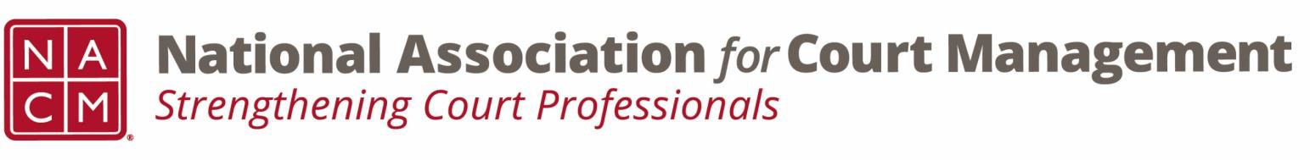

# **Governance Committee Agenda**

**October 2, 2024, 3:00 p.m. Eastern via Zoom**

Zoom link: https://zoom.us/j/93807989162?pwd=ZjV5S0pDOW1WalN6eFYwakkzTm03Zz09

**Chair:** [Nicole Zoe García](mailto:nicole@nacmnet.org) **Vice Chair**: [Courtney Whiteside](mailto:courtney@nacmnet.org)

**Committee Page**

1. **Call to Order**
   1. Attendees: Nicole Garcia, Courtney Whiteside, Peter Kiefer, Kelsey Leggat, Kent Pankey, Mandy Sarkissian, Rick Pierce, Tina Mattison, Shirley Olsen, Stepanie Collier, Roger Rand, TJ BeMent
2. **Reports of Sub-Groups**
   1. Ethics Subcommittee – Peter Kiefer  
      Peter shared that Rick updated the committee on the two forthcoming original resolutions  
      CORE Committee having a lot of success with their regional sessions  
      Question of Ethics recorded conversations: Problem Analysis, including what happens when you are called upon as a Court Administrator to analyze the problem and learn there is a group opposed to the court’s proposed solution for solving the problem. Learn about a problem occurring nationally but your court has chosen to go in another direction; how do you as a court administrator deal with that?  
      You have a problem but the solution has already been determined but you have to still complete a problem analysis. How do you write a problem analysis with a solution when the solution has been determined all along.
   2. Resolutions Subcommittee – Nicole Garcia
      * Potential Original Resolution re Change in nomenclature from “special master” to “court-appointed neutral” – Discussion by all
      * Grammatical changes made.
      * Motion to present to the board- Peter Kiefer, Second- Stephanie Collier
      * Motion passed- 9 Aye, 1 Nay
      * TJ & Rick draft resolution to honor Mary McQueen to pitch at November meeting
3. **Unfinished Business**
   1. List of committee goals requested by Kent- Nicole to send out
   2. Support kit for court employee appreciation week
      * Asking for volunteers
      * Mimic jury appreciation week
      * Expansion of 2023 NACM resolution
4. **New Business**
   1. 2025 Conferences Call for Proposals!
5. **NACM Committee Updates**
   1. No additional committee updates
6. **Adjourn**
   1. Motion to adjourn- Peter Kiefer, Second- Courtney Whiteside
   2. Meeting adjourned at 2:39pm