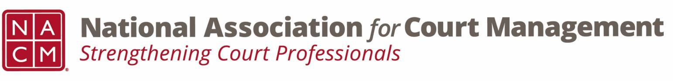

# **Governance Committee Minutes**

**December 4, 2024, 3:00 p.m. Eastern via Zoom**

Zoom link: <https://us06web.zoom.us/j/81227189771?pwd=bRWbW5ruaslCR6VMp5aM1MEXPmXUPP.1>

**Chair:** [Nicole Zoe García](mailto:nicole@nacmnet.org) **Vice Chair**: [Courtney Whiteside](mailto:courtney@nacmnet.org)

[**Committee Page**](https://nacmnet.org/governance-committee/)

1. **Call to Order 3:04pm EST**
   1. Attendees: Nicole Garcia, Courtney Whiteside, Stephanie Collier, Craig Washburn, Creadell Webb, Kelly Hutton, Kent Pankey, Kristie Collier, Mandy Sarkissian, Mark Dalton, Mark Weinberg, Shirley Olson
2. **Approval of Minutes**
   1. Mandy moves, Kent seconds. Minutes are approved as submitted.
3. **Reports of Sub-Groups**
   1. Ethics Subcommittee – Courtney Whiteside  
      October/November meeting- presentation by Roger Rand on Data Literacy

January- presentation by Creadell Webb

February- begin review and revision of Code of Conduct, Canon 5

Peter- Question of Ethics podcast from September out & November in editing

* 1. Resolutions Subcommittee – Nicole Garcia  
     Goal to be out for midyear. Drafted by TJ BeMent. Mark asks if we should make mention of work in courts prior to NCSC? Committee response: yes

1. **New Business**
   1. Strategic Plan/Annual Goals

*Court Employee Appreciation Toolkit.* Sub-committee/work groups coming in Jan 2025- volunteers needed. Kristie- municipal court appreciation week in GA- modeled after TX [https://www.tmcec.com/mtsi/municipal-courts-week/](https://urldefense.com/v3/__https:/www.tmcec.com/mtsi/municipal-courts-week/__;!!KLEl7LSNBzLtGRk!cSOQ9r5LRIxji5q4RnvG_VU8cOsKJE0qGSHBykHP86s3yy6TIVrep2sgiYR3e-TVIKZz3Rh2iG5wzvWHA0cTTQlOg6RSytT5O191EACFTHC6$). Mandy- brochure attached  
*Strategic Focus 4- Association Governance*. 1. Association documents- Possible subcommittee. Revisit in 2025. 2. Original resolutions to use our voice to support the profession. Mark- what about the resolutions that we support but aren't original to NACM? Nicole- co-sign will continue but looking to create our own

1. **Unfinished Business**
2. **NACM Committee Updates**  
   DEI- ensure committee aware of original resolution for Court Appointed Neutrals. Each meeting has a theme  
   Membership- roundtables in 2025- limited jurisdiction 1/30, tribal 2/27, federal 3/27 at noon EST. New member Zoom calls. ECP, State Organization, International. Membership promo running through Dec 31, multi-member discount  
   Conf Dev- registration is open for midyear to 1/17, scholarship open until 12/13; 5 available, 3 applications  
   State Assoc- next meeting 12/12 at 2EST  
   Past Pres- next meeting 12/16 at 3EST
3. **Adjourned 3:45pm**  
   Interest in any committee work email Nicole