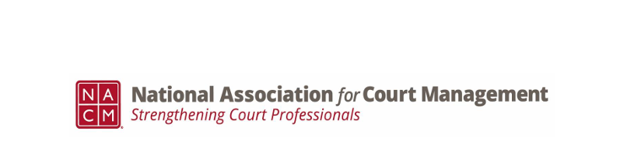
Minutes of the Conference Call of the Ethics Subcommittee
Thursday, September 26. 2024
3:00 p.m. Eastern Time

In attendance: Samantha Wallis, Stacy Worby, Rick Pierce, Peter Kiefer, Creadell Webb,
Erika Schmid,

- Minutes of the August 22, 2024, meeting were approved.

- Rick Pierce discussed the two motions the Governance Committee is considering:

  - Changing the title of interpreter to court neutral
  - Honoring Mary McQueen

- The next Conference Development Committee Meeting will be held on October 15th at 3:00 Eastern Time.

- Rick and Samantha discussed the successful presentations of the CORE Wyoming,
Washington State, Pennsylvania, and Tennessee

- No New Business

Meeting Adjourned

Next Meeting October 24th at 3:00 p.m. Eastern Time.

