 |  | National Association
 |  | for Court Management | Strengthening Court Professionals
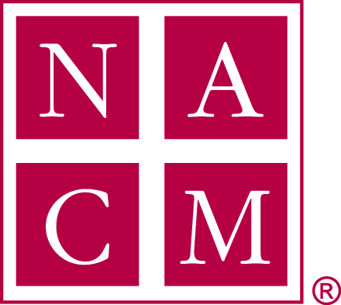

Conference Proposal for Future NACM Conferences (Draft)

Current NACM Conferences
Midyear Conference:
Sunday (evening) – Tuesday (lunch) | $475/member (approx.) | 3 plenary  16 breakouts (4 time slots) + 4 SIG | 3 hours  4 hours

Annual Conference:
Sunday (evening) -Thursday (lunch) | $575/member  (approx.) | 6 plenary  48 breakouts (8 time slots) | 6.5 hours  8.25 hours

Proposal (see schedule of event templates)
Objectives:
- Increase number of education sessions to the midyear conference
- Reduce drop off numbers at the annual conference
- Reduce conference registration costs for members
- Increase registration numbers overall

Midyear Conference:
Sunday (evening) – Tuesday (end of work day) | $425/member (approx.) | 4 plenary  22 breakouts (6 time slots) + 2 SIG sessions | 4 hours  6 hours

Annual Conference:
Sunday (evening) – Wednesday (end of work day) | $550/member (approx.) | 4 plenary  48 breakouts (8 time slots) + SIG sessions/Committee Meetings | 4 hours  8 hours

- NACM Savings at annual conference:
  - Officer rooms and per diem by one night
  - Consultant rooms and per diem by one night
  - Conference cost reductions
    - Photographer
    - Audio/video
    - Live-streaming
    - Reduced plenary speaker costs
    - Thursday food and/or beverage

- Member Savings:
  - Registration rate
  - Hotel and per diem
  - Reduced time out of the office (annual)

National Conference Comparisons
National Association for Court Management | Sunday – Thursday | Member $575
National Association of Drug Court Professionals | Sunday – Wednesday | Member $600
National Court Reporters Association | Thursday – Sunday | Member $595
National Conference of Appellate Court Clerks | Sunday-Thursday | Member $450
National Conference of Bankruptcy Clerks | Monday – Thursday | Member $375
National Association of State Judicial Educators | Sunday – Wednesday | Member $545
Mid-Atlantic Association for Court Management | Sunday – Wednesday
NAPSA National Association of Pre-trial Services Agencies | Sunday – Wednesday | Member $400

June 13, 2017

