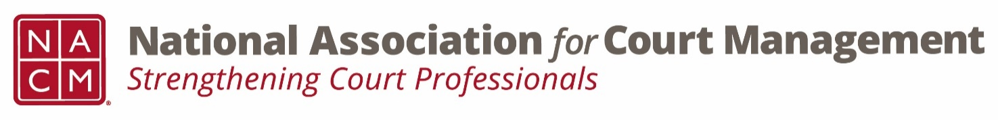

**OFFICERS MEETING AGENDA**

**Friday, July 20, 2018 – Room 301**

**1:00-3:30 p.m.**

*Lunch Southern Elements with NCSC @ 12:00 p.m.*

*Dinner with Mary McQueen – meet in lobby at 6:00 p.m.*

1. **Approval of May, 1, 2018 minutes** *Vicky Carlson*

**

1. **Conference Crisis Plan**  *Janet Reid*
2. **Preview Saturday Board Agenda** *Vicky Carlson*
3. **Conference Announcements Review** *Vicky Carlson*
4. **NCSC Report** *Jesse Rutledge*
5. **Other Business** *All*