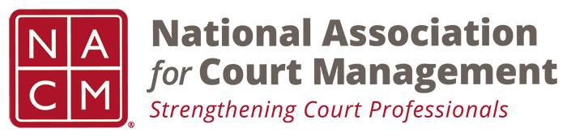

NACM MEMBERSHIP SERVICES COMMITTEE MEETING
Wednesday July 25, 2018 @ 11 AM Eastern Time

Call to Order Michelle Dunivan
Welcome and Roll Call Michelle Dunivan
Board Meeting recap Michelle Dunivan
Update and review of State Assn. Memberships Jeff Chappel
Scholarship and awards review Jeff Chappel
LinkedIn Social media promotion Jeff Chappel
Membership appreciation Jeffrey Tsunekawa
Subcommittees:
- State Associations TJ BeMent
- International Committee Michele Oken
- ECP Angie VanSchoick
New Business

Meeting Schedule
  - October 2, 2018
  - November 6, 2018
  - December 4, 2018
  - January 8, 2019
  - February 5, 2019
  - March 12, 2019
  - April 9, 2019
  - May 7, 2019
  - June 11, 2019
  - July 18, 2019- At Annual Conference

Adjourn

