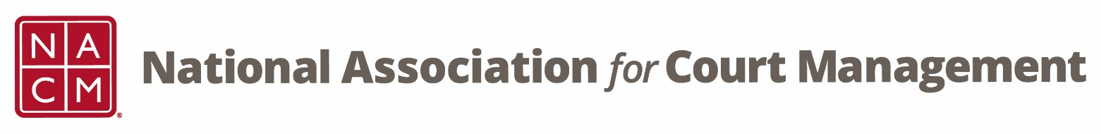

**Conference Development Committee Meeting**

Tuesday, September 17, 2024 at 3 pm EST

[Zoom Link](https://us06web.zoom.us/j/7103875466?pwd=RUplcUdyT0IreEdKalhCNWFiQTgwdz09)

Meeting ID: 710 387 5466

Meeting Passcode: 021675

**Agenda:**

1. **Welcome and Introductions**
2. **Annual Conference Debrief**
   1. **Committee Comments**
   2. **Survey Results**
3. [**2025 Conferences**](https://nacmnet.org/conferences/upcoming-conferences/)
   1. **Locations**
   2. **Theme and Graphics**
4. **Subcommittees**
   1. [**Call for Proposals**](https://nacmnet.org/conferences/call-for-proposals/)
   2. **Public Relations**
      1. **Conference Hype**
      2. **Know Before you Go**
      3. **App Navigation**
   3. **Hosts – Roger and Kristie**
   4. **Virtual Attendees & MC**
   5. **40th Anniversary**
   6. **Conference Awards and Conference Scholarships**
5. **Other Ideas for the Conferences**
6. **NACM Committee Updates**

**2024-25 Meeting dates**

October 15, November 19, December 17, January 21, March 18, April 15, May 20, June 17