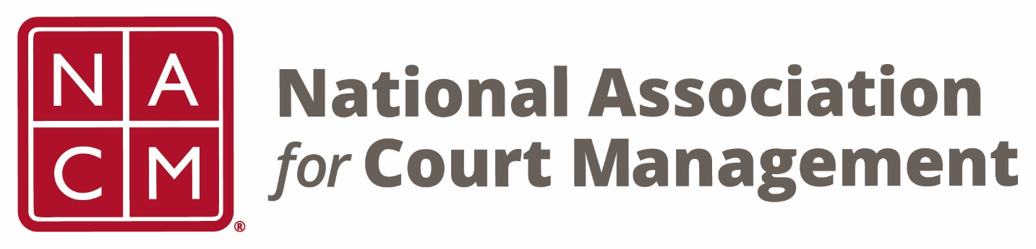

NACM 35th President
2019-2020

Will Simmons
Board Accomplishments

- The Association and this Presidency were greatly impacted by the Covid19 Global Pandemic.

- The Midyear Conference was held in Charlotte despite many states travel bans and the need for attendees to sign indemnity waivers.

- Due to travel bans and gathering size restrictions the Annual Conference scheduled for New Orleans was cancelled. Hotel contractual obligations were moved to 2024.

- The Annual Conference was moved to a fully virtual format and was conducted successfully.

- The first virtual State of the Profession address was delivered highlighting pandemic and social justice issues.

- Social Media Guide was finalized and released.

- DEI Subcommittee was formed following adoption of a Diversity Resolution.

- The Global Pandemic caused a conference cancellation and reduced membership with concomitant impact on budget. Despite these challenges, NACM remained vibrant.

