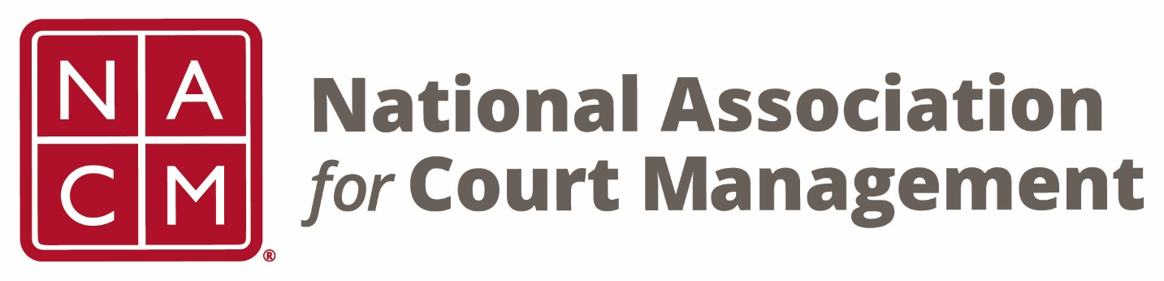

NACM 29th President
2013-2014

David Slayton
Board Accomplishments

- Oral History Project utilizing Past Presidents formalized.

- Initiated changes to COSCA/NACM Joint Technology Committee including an amendment to the CITOC Charter. Began slow phase out of the Forum for the Advancement of Court Technology (FACT).

- Initiated live streaming of plenary presentations and select sessions at the annual conference.

- Approved concept to explore a Joint Conference with the International Association for Court Administration (IACA).

- Continued Core Competencies Review and Update.

- Completed Guides on Technology, Human Trafficking, and Elders for courts across the nation.

- Initiated update of NACM National Agenda by 2015.

- Development of procedures and scripts for dealing with contested and uncontested elections at NACM Business Meetings.

- Negotiated and approved NACM/NCSC MOU for 2015 – 2017.

