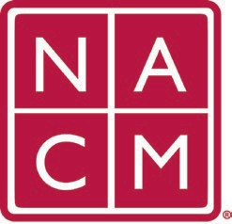
National Association
for Court Management Strengthening Court Professionals
STATE ASSOCIATIONS SUBCOMMITTEE
Agenda

August 3, 2023 @ 1PM PT / 4PM ET
Chair: Jeffrey Tsunekawa
Committee Page

- Welcome and Introductions
- Overview of State Associations Subcommittee
- Feedback from NACM Annual Conference Leadership Seminar
- Feedback from NACM Annual Conference
- Roundtable Desired Discussion Topics
- New Business
- Adjourn

Future Meeting Dates:
September 7
October 5
November 2
December 7

Thank you for your time!

Association Services: National Center for State Courts, 300 Newport Avenue, Williamsburg, VA 23185 (757) 259-1841, Fax (757) 259-1520
Home Page: http://www.nacmnet.org

