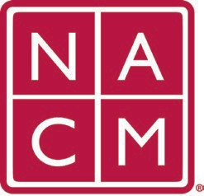
National Association
for Court Management Strengthening Court Professionals
WEBSITE COMMITTEE
AGENDA
April 5, 2023 @ 2:00 p.m. ET
Chair: Roger Rand
Committee Page

- Review and Approval of minutes from January 4, 2023 Meeting.
- Old Business
  - Core Champion Page
  - Change Requests
    - 3/1/23 Request to add Social Media Subcommittee Page
  - Howell to John Thomas switch 4/1/23
    - Meeting, Roger to review NACM’s agreement with John Thomas.
    - Roger to set a meeting with a Sales vendor from Nexcess to get a quote for maintenance and a document library with Nexcess starting in 2024.
  - Video Gallery to Conference Videos – Still to test
- New Business
  - Governance Response Form
  - Request for Information – Will go to Board for Review
Future Meeting dates.

June 7, 2023
May 3, 2023 July TBD at Annual Conference

Thank you for your time and we look forward to working with you this NACM year.
Association Services: National Center for State Courts, 300 Newport Avenue, Williamsburg, VA 23185 (757) 259-1841, Fax (757) 259-1520
Home Page: http://www.nacmnet.org

