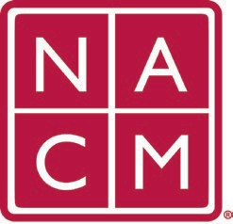
National Association
for Court Management Strengthening Court Professionals
WEBSITE COMMITTEE
December 7, 2022 @ 2:00 p.m. ET
Chair: Roger Rand
Committee Page
- Review and Approval of minutes from November 2, 2022 Meeting.
- Change Requests (Roger)
  - CORE Champion Update (Kelly Hutton)
- Old Business
  - Stage Overwritten with Production
  - Resource Index
- New Business

- Future Meetings
Future Meeting dates.

January 4, 2023
February 1, 2023 June 7, 2023
March 1, 2023 July TBD at Annual Conference
April 5, 2023
Thank you for your time and we look forward to working with you this NACM year.
Association Services: National Center for State Courts, 300 Newport Avenue, Williamsburg, VA 23185 (757) 259-1841, Fax (757) 259-1520
Home Page: http://www.nacmnet.org

