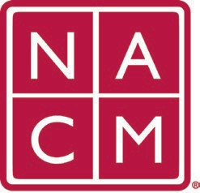
National Association
for Court Management Strengthening Court Professionals
WEBSITE COMMITTEE
December 7, 2022 @ 2:00 p.m. ET
Chair: Roger Rand
Committee Page

Attendees: Rick Pierce, Kelly Hutton, Kent Pankey, Roger Rand, Mae Swisher, Joe Calogero

- Review and Approval of minutes from November 2, 2022 Meeting.
- Change Requests (Roger)
  - CORE Champion Update (Kelly Hutton)
    - Roger will submit a change to add a direct link to CORE Site on NACM homepage
    - Roger will submit a change: Currently, there is a ‘Where’s there’s support…’ banner on the NACMNET.ORG home page – change this banner to CORE and have it link to the Core website.
    - Roger to submit a change: Under Resources in Mega Menu – change the current link to Core Competences to a link to the Core Homepage
  - CORE Homepage
    - Kelly to turn in change request to add a menu of options to the CORE homepage
    - Roger will give WebTeam and admin account for CORE Wordpress access
- Old Business
  - Stage Overwritten with Production
  - Resource Index
- New Business
  - Roger is sharing a version of the NACM Website change request form with the JTC for making changes to the NCSC/JTC Site.

- Future Meetings
Future Meeting dates.

January 4, 2023
February 1, 2023 June 7, 2023
March 1, 2023 July TBD at Annual Conference
April 5, 2023
Thank you for your time and we look forward to working with you this NACM year.
Association Services: National Center for State Courts, 300 Newport Avenue, Williamsburg, VA 23185 (757) 259-1841, Fax (757) 259-1520
Home Page: http://www.nacmnet.org

